CHAPTER 1 INTRODUCTION TO THE STUDY

Background of the Study and Theoretical Framework

Language is the primary basis of all communication and the primary instrument of thought. Language learning is an active process that begins at birth and continues throughout life. Language development is continuous and recursive. Students enhance their language learning by using what they know in new and more complex contexts. According to Ahmadi (2018), technology has been used to both help and improve language learning. With the resurfacing of Baybayin in the modern time, the scripts that survived through centuries of colonization are a legacy. Baybayin, a writing system that is believed to be part of the Devanagari script family that shares similarities with the scripts of Indonesia and Northern and Southern India (Miller, 2013), is being developed and innovated for a better learning process through the help of technology.

Since everything can be seen with just one tap from their phone, students are not fond of books and newspapers. As studied by Shen (2007), it was revealed that 83.9% of students read online information often every day and 69.3% of them read emails. In contrast, only 31.4% read newspapers, and 33.1% read magazines. They find it hard to look for information in books as they have to scan each part of the book to find the one they are looking for. Shenton, A.K. and Dixon, P. (2004) mentioned in their study that if too much information were retrieved by information-seeking young people, frustration tends to arise. Because of this, students are absorbed in the latest technologies, and one of those is games.

Papadakis et al. (2013) stated that game-based application has the potential in enhancing a student's motivation and engagement in education. Games are also very adaptive in technology where they range from consoles, PCs, and now in mobile. Along with the fact that Baybayin script is gaining popularity today, it is also a potential writing system that Filipinos can use in their everyday lives. But not everyone knows and understands this ancient writing script. Thus, the researchers have come up with a study that lets people learn Baybayin in a knowledgeable yet fun way. With the revival of Baybayin in modern times, the research team proposed to make a Baybayin game application entitled Lak-Bay.

Through this study, the researchers could help people learn about Baybayin and at the same time, spread Filipino culture to those who would download the application. The goal of this study is to make the people more knowledgeable about Filipino culture and history while also trying to gain new knowledge regarding the ancient Filipino writing script.

Theoretical Framework

This study anchored its theoretical foundation on Jonathan deHaan’s learning language through video games, specifically how language learners can benefit from video games. In this section, deHaan’s theory is explained how it is related to the research.

Jonathan deHaan’s Learning Language through Video Games

According to Jonathan deHaan (2005), video games may be used to educate players who want to learn a foreign language. Results coming from various studies, such as NEXT-Generation: Educational Technology by Joel Foreman (2003), support the use of video games to learn language. In the mentioned study, Joel Foreman discussed how video games could be effectively used to replace large lecture courses. Current language teaching methodologies also support this.

One trait that may make the players able to acquire language is how they are very engrossed in game play which shows the level of involvement in a task. The more they are involved in doing a task, the more they will be able to acquire language.

Repetition in video games like the constant set-up of mini battles in role playing games and the frequent use of menus can allow a language learner to be constantly exposed to the language they want to learn. This makes the learner be familiar with the words that are used which makes them acquire new knowledge in the language.

Objectives of the Study

The objective of the study was todevelop a Baybayin game-based learning application. Specifically, it aimed to:

1. introduce and promote the Baybayin script and its history;
2. contribute to the lack of Baybayin learning resources;
3. let users familiarize characters of Baybayin and learn how to form a word or phrase; and
4. evaluate the game using ISO/IEC 25010:2011.

Significance of the Study

This study would be beneficial to the following groups of people:

**Students**

Students will be able to learn and familiarize with the Baybayin script. The result of this study will help students acquire knowledge in Baybayin and its history.

**Teachers**

Teachers may use the result of the study as a learning material to teach Baybayin. This study will make teaching more innovative and enjoyable.

**Future Researchers**

Future researchers may use this study for further research. The result of this study may serve as a reference and resource for future studies related to the topic.

Definition of Terms

For better understanding, the following terms were defined conceptually and operationally:

Baybayin is an ancient pre-colonial Philippine writing system. The term Baybayin literally means "to spell" in Tagalog (Definitions.net, n.d.).

In this study, “Baybayin” was the content of the game application that the researchers developed.

Game is a structured form of play, usually undertaken for entertainment or fun, and sometimes used as an educational tool. (Collinsdictionary.com, n.d.).

In this study, “game” referred to the type of application the researchers are going to develop.

Game-based learning is where game characteristics are embedded within learning activities. It is also an active learning technique where games are used to enhance student learning (tophat.com, n.d.).

In this study, “game-based learning” referred to the technique used to teach Baybayin script in a game application.

Game Engine is created to develop games, just like any other IDE for any particular language programming (Studytonight.com, n.d.).

In this study, “game engine” referred to the type of technology that would be used to develop the game application.

Languageis a system of conventional spoken, manual (signed), or written symbols by means of which human beings, as members of a social group and participants in its culture, express themselves. The functions of language include communication, the expression of identity, play, imaginative expression, and emotional release (britannica.com, n.d.).

In this study, “language” referred to the process of communication using written symbols.

Scriptis the letters or characters used in writing by hand; handwriting, especially cursive writing. (dictionary.com, n.d.).

In this study, “script” referred to the ancient writing system called Baybayin.

Technology is the application of scientific knowledge to the practical aims of human life or, as it is sometimes phrased, to the change and manipulation of the human environment (britannica.com, n.d.).

In this study, “technology” referred to the advanced use of gadgets or devices in learning and teaching.

Delimitation of the Study

This study is limited to creating a game application that is only a prototype version. The prototype version of the game limits certain areas for the researchers to use. This game application runs only on android devices. The topics from the game-based learning application consist only of content about Baybayin history and characters. The researchers used the modified version of the Baybayin script. The Baybayin Tutorial is presented in the form of slides. The topics in the Baybayin Tutorial were the basis of the questions asked in every stage. The prototype version of the game has two regions. The 1st region has four stages while the 2nd region has two. In every stage, the player has three lives, it would reset every time he or she proceeds to the next one. The difficulty of the game was based on the topics taken and the countdown timer was set by stage. By choosing the correct answer, the life of the enemy will be reduced. The same will happen to the player if he or she chooses the wrong answer.

CHAPTER 2 REVIEW OF RELATED STUDIES

## Review of Existing and Related Studies

*Baybayin*

According to Cabuay (2009), "Alibata", a term coined by Professor Paul Versoza in the early 1900s is incorrect. The correct name for the native system Tagalog used as their writing is actually "Baybayin." It comes from the root word Baybay which means, "to spell." This native script was used to write poetry and announcements in natural materials such as bamboo.  Cabuay (2009) stated that one of the causes of the demise of the script is the Spanish, though they are also the reason why information about the script continues to exist today. The fact that natives used to write on organic materials severely shortened the lifespan of the scripts. It can also mean that Baybayin died a natural death.

The author mentioned without the tattoo movement, there wouldn't be much interest in the script. Baybayin has resurfaced in the modern world, and the ones who led this resurgence were the Filipino-Americans. Baybayin has been gaining popularity on the internet and in different mediums through the years. In addition to this, Cabuay (2009) also mentioned that there are still a few tribes that use a mutated version of Baybayin until today; they are the Buhids, Hanunuos, and Tagbanwa.

In the study of Pitogo (2015), the Hanunuo-Mangyan has consciously preserved the Surat-Mangyan from the demise that many Baybayin scripts went through. Surat-Mangyan, in its enhanced form, is very much alive and used in their schools and everyday life. Pitogo (2015) stated that Surat-Mangyan has an extreme value. It is a living Baybayin script embedded in the ecocentric consciousness and traditions of the Hanunuo-Mangyan. It has survived through centuries of colonization, and it has articulated effectively the language of their social life. The author indicated that without the Surat-Mangyan, it would be hard to imagine how over 20,000 ambahans collected and transcribed by Postma will survive the colonial and post-colonial eras.

The Ambahan and Surat-Mangyan form an inseparable national legacy. It is a glimpse of the Philippines' wealth during pre-Hispanic consciousness, philosophy, literature, art, and poetic heritage. Pitogo (2015) indicated that it is an integrated piece representing a metaphoric expression of the poetic genius and sensitivity of Indigenous Filipinos before Christian and Western influences.

*Game-based Learning*

As studied by Chevtchenko (2013), games have been a part of human societies throughout history. It has become increasingly common with the advent of computers and the internet. Understanding games and their exceptional motivational power can be beneficial in a variety of fields and applications Chevtchenko (2013). Furthermore, he stated that incorporating game elements into non-game settings like education is an attempt to harness motivational power that could influence the behavior.

Chevtchenko (2013) added that the lack of a systematic method for creating gamified experiences is one of the major issues in this approach. There is no perfect formula for creating educational games and effective designs involving innovation and uniqueness. Nevertheless, the author has successfully presented an overview of some game elements and techniques that can be used to elicit motivation, supported by an analysis of the underlying psychological and behavioral mechanisms involved in the process.

Zainuddin et al. (2020) stated that recently, the use of digital games in language learning has increased. Teachers and researchers are turning their attention towards game-based learning for effective learning. It is the development and practice of physical technologies and software for educational purposes in multiple contexts Zainuddin et al. (2020). The authors mentioned that game-based learning is also a virtual world game where a mix of playing and learning is applied. The students will be able to have fun without feeling that they are learning. It makes learning more meaningful and effective; it generates an increase in students’ skills and motivation.

The authors analyzed that digital game-based language learning in teaching and learning was well-received by their target audience. The result of the study shows that there was an increase in students' vocabulary and motivation in learning. The study suggests several types of games that can serve as a guideline to game developers in creating interactive digital game-based language learning namely Jigsaw Puzzles, Poison Box, Role Play, Adventure, etc.

*MindSnacks* is creating a platform of multiplayer learning games across touch-based devices. It is an educational application that has versions of Spanish, French, Italian, and Portuguese. It includes various addictive mini-games that teach vocabulary, writing, reading, and listening skills to foreign language learners.

*Quizlet* is an American online study application that allows students to study various topics via learning tools and games.

*Duolingo* is an American language-learning website and mobile application. It is an educational application that offers a skill tree of lessons that uses listening exercises, flashcards, and multiple-choice questions to drill learners on new words, phrases, and sentences.

*Baybayin as Cultural Identity*

According to Camba (2021), there are research findings that show that Baybayin provides a national visual identity or symbol to the Filipinos. They also show a sense of visual reinforcement that identifies the Filipino culture. This writing system also serves to promote the Filipino culture to Filipinos who are not aware of it and also to other people that are interested to learn more about the Filipino culture. Also, this writing system shows a sense of cultural pride for the Filipinos.

Also according to a study conducted by Taylor and Usborne (2010), reviving a traditional language to clarify cultural identity can play a positive role in promoting well-being. This shows that the revival of Baybayin can have a big impact on the spreading of culture of the Filipinos and also has a big impact on the individual.

The result of Camba’s research showed that the revival of Baybayin is giving out a clearer Filipino cultural identity and better socio-psychological well-being to the people who use it. It shows a sense of belongingness to their cultural group, a greater social connection among the people and greater recognition from others for having their own written language. Reviving Baybayin can also show that Filipinos can have their own written script like other cultures and this is also a way to preserve our tradition that was once lost after colonization.

*University Students’ Perspective on Baybayin*

Gayandao & Taripe (2019) assessed the knowledge and attitudes of university students from Quezon City regarding Baybayin and the proposal for a national writing system. The results show that the students have little knowledge about Baybayin but they are still interested in learning it.   
 The university students believe that Baybayin is important especially in relation to its usage and impact on the economy, education, security and military operations, sports, political cooperation, and tourism. Though they are more familiar and knowledgeable on other Asian scripts, they are willing to learn more about Baybayin if this is introduced and included in the curriculum. This shows that people know less about Baybayin because it wasn’t introduced to the masses but due to the revival of it, many are curious to learn more about it. The House Bill 1022, or better known as National Writing System Act, was proposed to protect, preserve, and conserve this ancient script by requiring all government agencies and local government units to use Baybayin in their communication systems. The Department of Education is also tasked to promote this writing system in schools. Due to this bill, people are expected to learn or to be familiarized with the script.

CHAPTER 3 RESEARCH DESIGN AND METHODOLOGY

Description of the Proposed Study

The proposed study centered on promoting and introducing Baybayin script through a game application called "Lak-bay." It is an educational, adventure, and side-scrolling game that aims to teach Baybayin script using a multiple-choice quiz. This study was limited to creating a game that is only a prototype version. Certain areas were limited and the difficulty varied by region or stage of the game.

This study is anchored on the assumption that the target audience recognizes a portion of Baybayin as it has been resurfacing in public through the years; they would want to learn Baybayin and know more about its history. The prototype version of the game application elicited useful responses from the target audience. It is functional and it is easy to play.

Before the development of the game application, the first precondition was to plan and formulate the idea of the game. There were weekly meetings to discuss and slowly decide the outcome of the application. Another precondition was the continuous gathering of resources about Baybayin and other related studies. Moreover, it will be helpful to obtain a Baybayin expert that will guide and correct the proper use of Baybayin.

Components and Design

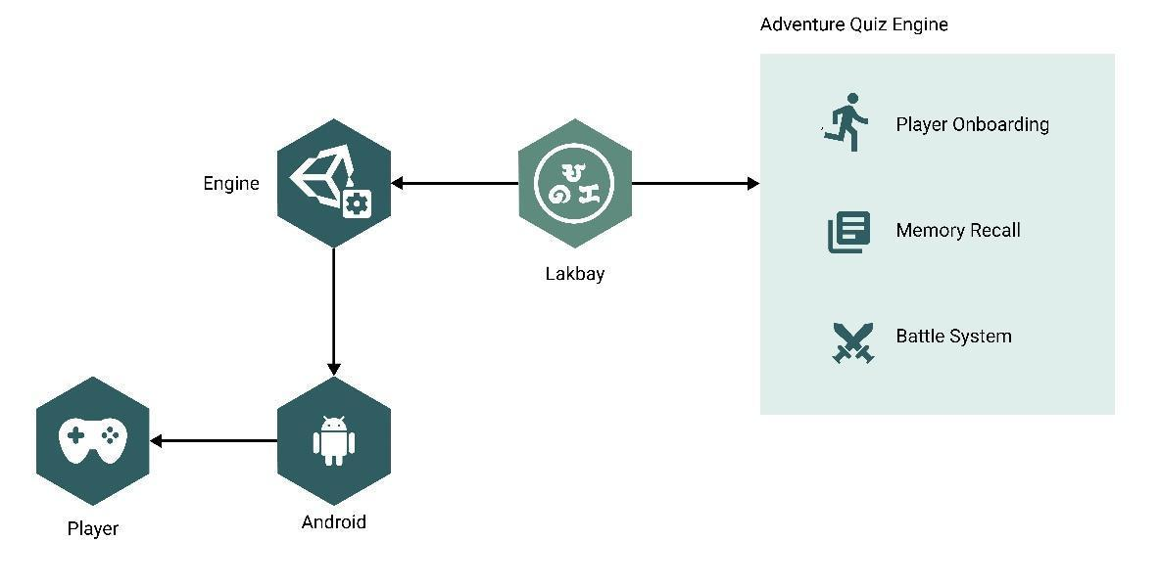

**Figure 1.** Game Architecture

Figure 1 shows the fundamental process of how the game is built and its output. It includes the Game Engine, key points of the game, operating system, and target user of the game.

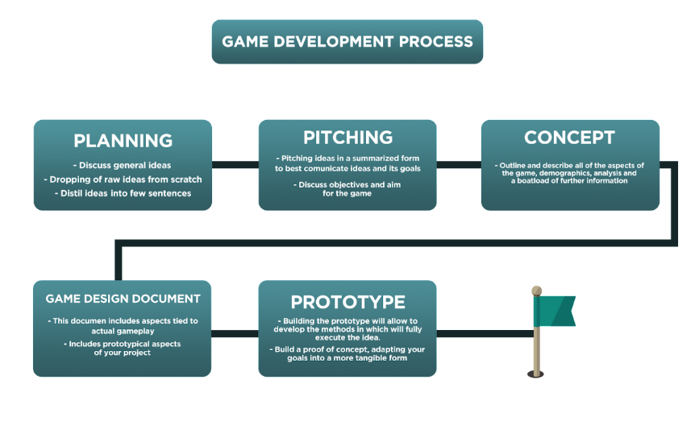

**Figure 2.** Game Development Process

Figure 2 shows how the game development process should start and how it will go along the way. By planning and discussing ideas, presenting and having suggestions to obtain the objectives, then proceeding to designing and making the prototype.

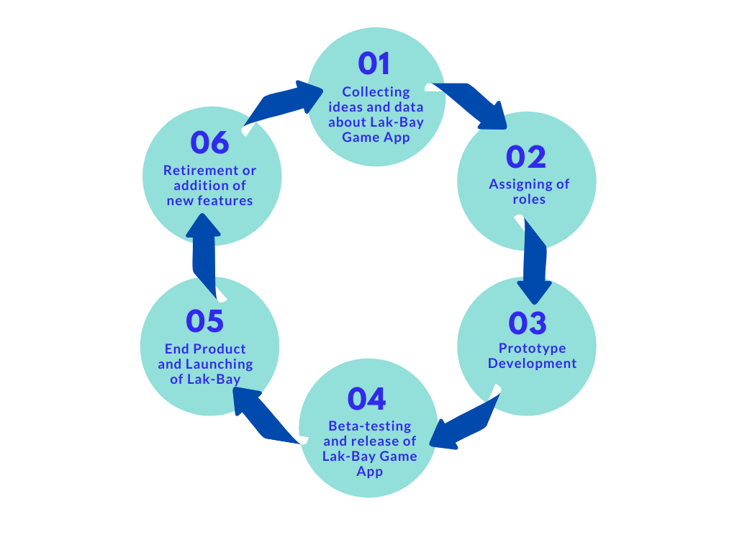

**Figure 3.** Systems Development Life Cycle (SDLC)

Figure 3 shows the System Development Life Cycle of Lak-Bay. Starting from the pre-production process of collecting ideas and data to create the game up to launching the End Product Lak-Bay.

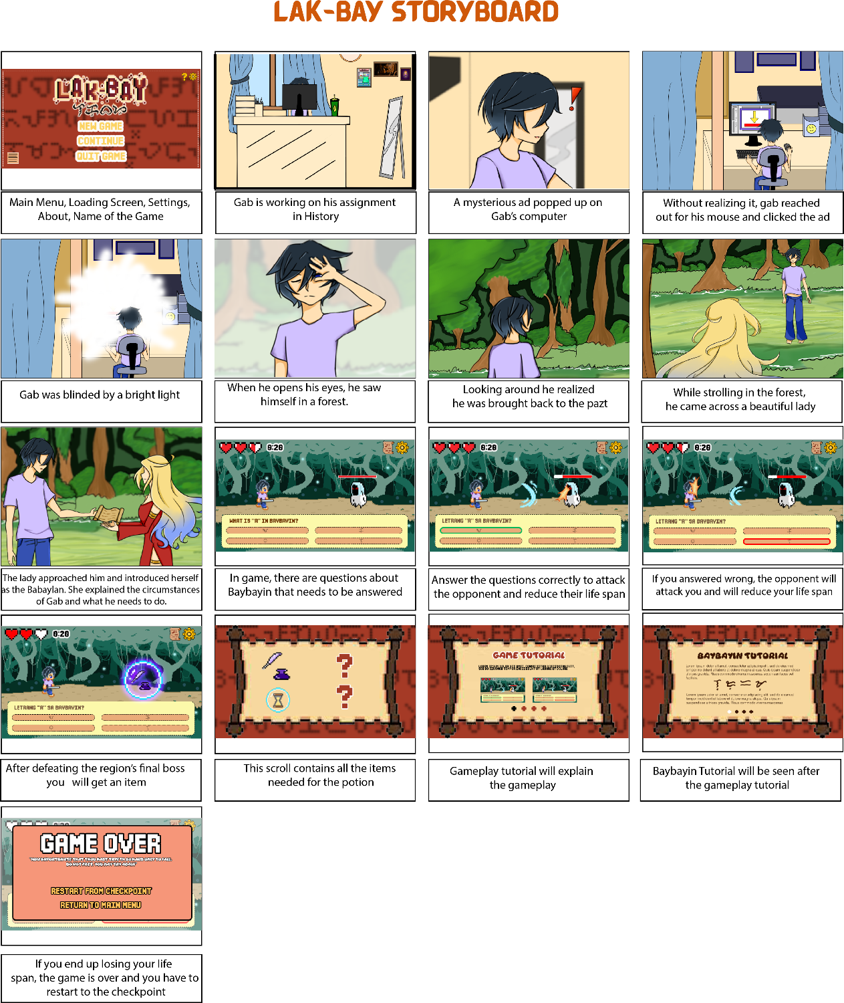

**Figure 4.** Lak-bay Storyboard

Figure 4 shows the visuals of the game, where a story is being told. It reveals the sequence of events once the player opens the game application.

**Game Design Document**



**Figure 5.** Game Name

Figure 5 shows the visual design of the name of the game.

Game Summary

Play as Gab, a regular student working on his assignment when suddenly he was thrown back in time. And in order for him to go back to the present, the player must help him uncover and understand the secrets of the past to pave a way back from whence he came. Lakbay is a multiple-choice quiz game where the player must choose the correct answer in order to defeat the opponents and proceed to the next area. The player should collect all items that the Babaylan requires so that Gab may return home.

Key Features:

* Educational quiz game
* Adventure in a fantasy-esque world
* 2D pixelated side-scroller
* Monsters inspired by local myths and legends
* Learn more about our local historical script

Target Platform/s: Android

Business Model:

The game would be free to play. The revenue would come from the in-app purchases and ads. The player can purchase different kinds of game packs in the store. New levels and items would be unlocked when finishing a quest. The game would also have an autosave feature that allows the player to continue where they left off.

Game Overview

Theme: Fantasy

Setting: Fantasy/Parallel World

Genre: Adventure, Educational, RPG, Side-scrolling

Story and Gameplay

*Story* The story starts when the main character is working on his history assignment. He comes across an advertisement and clicks it. Then suddenly, light flashes before his eyes and in an instant, he is teleported into a forest. He was transported back in time. In a twist of fate, he meets a Babaylan that instructs him that he needs to find all the items to create a potion that would take him back to the present. This is where his journey begins.

*Characters*

* *Gab* – is a student that was accidentally teleported back to the past. He is a determined person who wants to go back to where he originally came from. He is also brave for fighting different kinds of monsters while on the search for the items of the magical potion.
* *Babaylan* – a beautiful shaman that helps the main character create the magical potion for him to go back to the future. She is the one giving him scrolls where the info for the items is put. She is there to help the main character when he needs certain items and potions during his quests.

*Core Gameplay*

* *answer-to-attack* - the player and the opponent will each have a life-bar. In order to launch an attack, the player has to answer the questions correctly. The questions will be presented in multiple-choice form. If answered incorrectly, the opponent would attack the player. Once attacked, the life-bar would be reduced by half.

Game Progression

Upon launching the game, the player will be greeted with a title screen. Upon starting a new game, an opening intro scene will be played to give some context about the game’s plot. After the cutscene has played, the tutorial phase will begin where the mechanics and gameplay will be explained by an in-game NPC. In terms of saving game progress, the game will auto-save at the start of every stage. If ever the player dies in a stage, they may restart from the last save point. The game is set to be an 8-bit 2D side-scroller with a fantasy-esque setting. It features up to five regions and will have four sub stages in each region. Each region will sport two bosses: one mid-boss and one final boss. In order to defeat enemies, the player has to answer questions related to Baybayin in the form of multiple choice. If the player answers correctly, the enemy will take damage. However, if answered incorrectly, the player will take damage instead. Upon clearing a stage or region, a key item will drop and after picking it up the player will automatically advance to the next stage or region. The goal of the game is to acquire all items in order for the main character to return to his own timeline.

Mission/Challenge Structure

* Choose the correct answer to launch an attack.
* Choose an answer within the time limit.
* Defeat the opponent to advance to the next level/stages.
* Collect the items needed by the Babaylan.

Game Objectives

The objective of the game is to

* familiarize the player with Baybayin characters;
* defeat the opponent by answering the questions correctly; and
* level up and collect the items in order to go back to their own timeline.

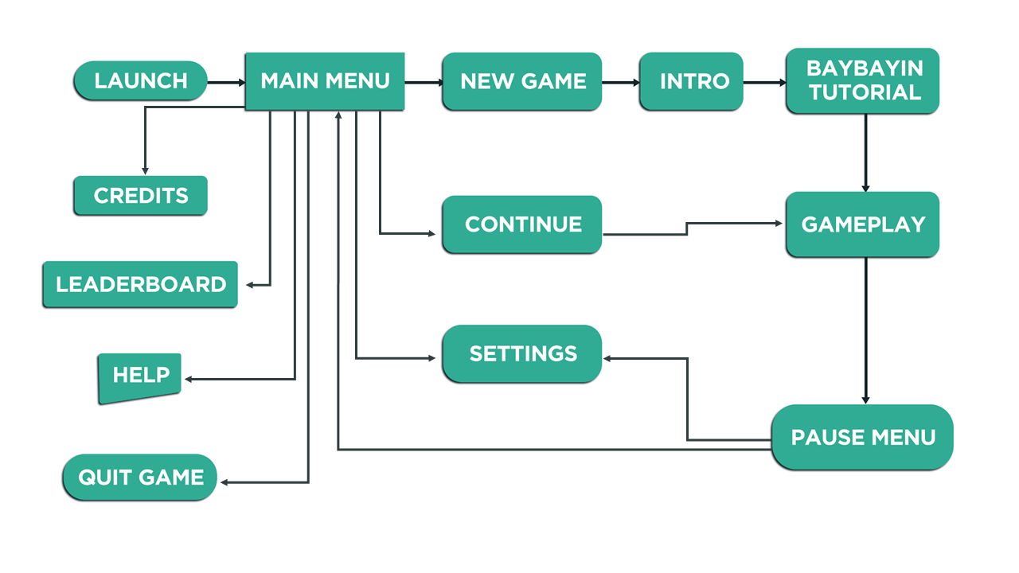

**Figure 6.** Play Flow

Figure 6 shows the flow step of the game as to where one would go once clicked the desired button.

Mechanics

*Objects*

* *Time-add* – additional time will be added to every question in the next stage
* *Attack Buff* – attack power will increase momentarily
* Sword (Weapon 1) – weapon that can be used in attacking; it will be equipped once picked
* *Bow and Arrow* (Weapon 2) – weapon that can be used in attacking; it will be equipped once picked
* *Quilt and Ink* – one of the items needed by the Babaylan
* *Scroll* – one of the items needed by the Babaylan

*Actions*

* *Auto-move* – character movement will be automated

*Losing*

The player loses when the lifespan is drained. One wrong answer can cause your lifespan to reduce. Consistent wrong answers mean the enemies can attack you, draining all your life. Once the life span is drained, a game over screen would show up and you would need to go back to the main menu.

*Replaying and Saving*

* *Auto-save* – upon entering a new stage the game will auto-save. If the player dies anytime in that stage, he or she may restart from the checkpoint.

User Interface/Screens

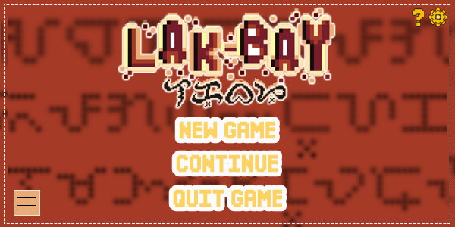

**Figure 7.** Main Menu

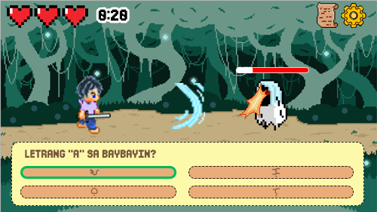

**Figure 8.** Gameplay Screen

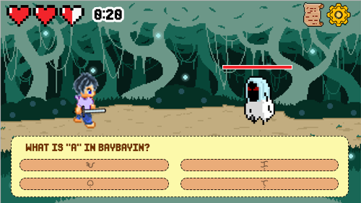

**Figure 9.1.** Controls

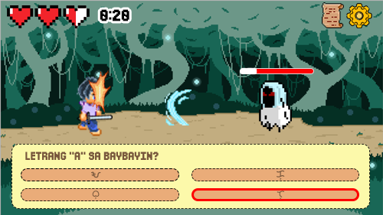

**Figure 9.2.** Controls

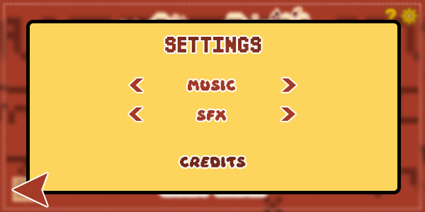

**Figure 10.** Settings Pop-up

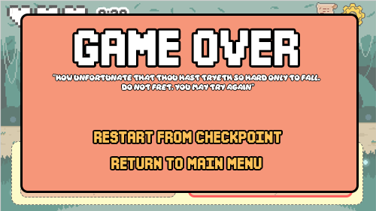

**Figure 11.** Game Over Screen

Figure 7 to 11 shows the user interface design of the game. It is the overview of what the output of the game should look like once developed. It also includes the art style, mood, and feel of the game.

**Levels/Stages**

Each region contains four stages which go as follows:

* 1st stage – Mobs only
* 2nd stage – Mid-boss
* 3rd stage – Mobs only
* 4th stage – Region’s Final boss

In total, there will be 12 enemies for each region. Each stage goes as follows:

* 1st stage – 5 Mobs
* 2nd stage – 1 Mid-boss
* 3rd stage – 5 Mobs
* 4th stage – 1 Final boss

**Asset List**

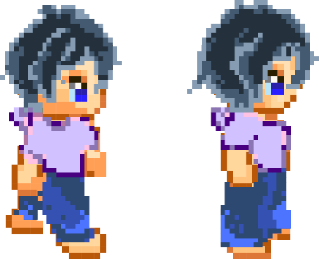  
Art (2D Pixel Sprite)

**Figure 12.** Gab Pixel Sprite  
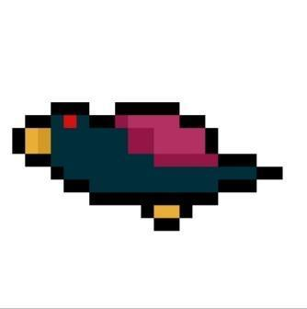

**Figure 13.** Enemy Sprite

Environment Art  
**Figure 14.** Enchanted Forest

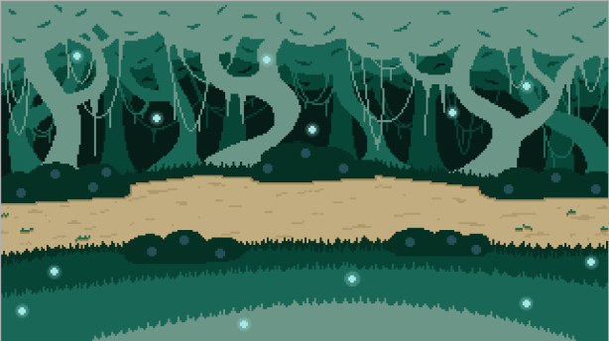

**Figure 15.** Lak-Bay Game Objects

|  |  |  |
| --- | --- | --- |
|  |  |  |
| 1. *Time-add Power up* | *b. Attack Buff Power up* | *c. Sword weapon* |
|  |  |  |
| *d. Bow and Arrow weapon* | *e. Quilt and Ink* | *f. Scroll* |
|  |  |  |
| g. *Container* | *h. Heart* |  |

Figures 12 to 15 shows the assets and art designs used for the game. Every art component is in 2D art style Pixel Sprite.

Sound effects (Free Sfx online)

* *Click/Tap sfx*
* *Timer sfx*
* *Power-up sfx*
* *Complete a stage sfx*
* *Sword attack sfx*
* *Melee sfx*
* *Flesh hit sfx*
* *Game over sfx*
* *Reward sfx*

Music

The researchers implemented royalty free music in the later stages of development.

CHAPTER 4 RESULTS AND DISCUSSION

Implementation

*Lak-Bay Development Using Unity*

The tool used to develop the game application “Lak-Bay” was Unity, version 2020.3.11f1 set in Android Platform. Important panels were divided into scenes; they include the main menu, tutorials, cutscenes, and the game itself. The stages were separated by scenes and connected using the Next Stage Panel. Unity uses C# for scripting, an object-oriented scripting language. After exporting the APK application, the researchers prepared the evaluation form for the target users with ISO/IEC 25010:2011 as the basis for the evaluation questionnaire.  
  
*Lak-Bay Baybayin Tutorial and Questionnaire*

The researchers were able to find a Baybayin Consultant from KUMO, an organization of learners and educators building a positive and progressive academic community online. Both tutorials and questions were based on the Baybayin Workbook of the group and other accumulated studies about Baybayin.

Lak-Bay Application Screen Captures

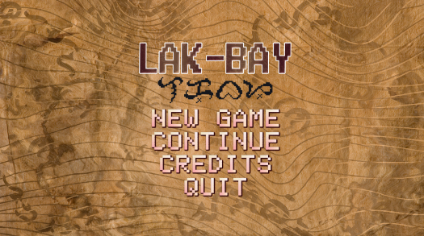

**Figure 16.** Main Menu

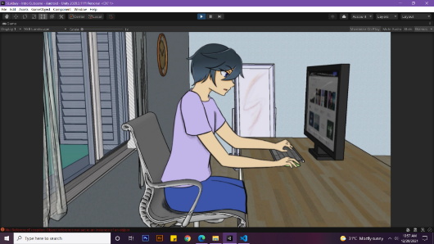

**Figure 17.** Intro Cut Scene

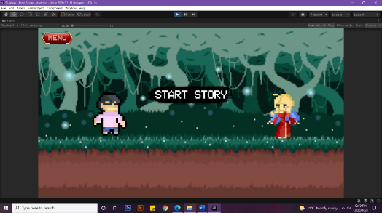

**Figure 18.** Intro Story

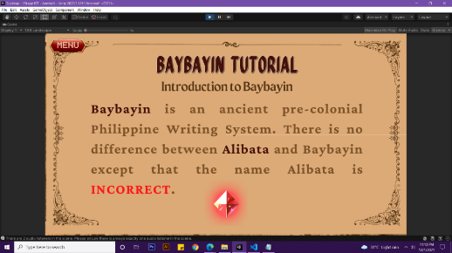

**Figure 19.** Baybayin Tutorial

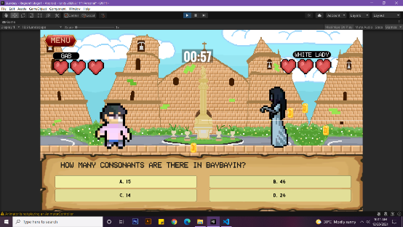

**Figure 20.** Game Scene

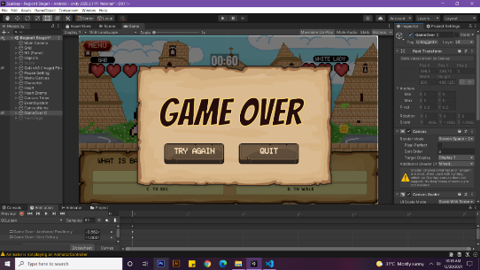

**Figure 21.** Game Over

Figure 16-21 shows the actual user interface output of the game.

*RESULTS INTERPRETATION AND ANALYSIS*

|  |  |
| --- | --- |
| Results | |
| Functional Suitability | 4.72 |
| Performance Efficiency | 4.42 |
| Usability | 4.69 |
| Reliability | 4.5 |
| Security | 4.45 |

***Table 1.*** *SHS Students Evaluation*

Table 1 shows the overall results by category of 20 Senior High School Students who evaluated the game.

In Table 1 there are five categories: Functional Suitability, Performance Efficiency, Usability, Reliability, and Security. Functional Suitability is the degree to which a product or system provides functions that meet the stated or implicit requirements when used under specific conditions. Performance Efficiency is the capability of the software product to provide appropriate performance, relative to the amount of resources used, under stated conditions. Usability is a measure of how well a specific user in a specific context can use a product or design to achieve a defined goal effectively, efficiently and satisfactorily. Reliability is the degree to which a system, product or component performs specific functions under specified conditions for a specified period of time. Security is the degree to which a product or system protects information and data so that persons or other products or systems have the degree of data access appropriate to their types and levels of authorization.

|  |  |
| --- | --- |
| Rating | |
| 4.21 - 5.00 | Very Satisfactory |
| 3.41 - 4.20 | Satisfactory |
| 2.61 - 3.40 | Neutral |
| 1.81 - 2.60 | Unsatisfactory |
| 1.00 - 1.80 | Very Unsatisfactory |

**Table 2.** Rating

Table 2 shows the five-point rating scale used to measure the result.

|  |  |  |
| --- | --- | --- |
| Mobile OS Testing | | |
| Android Version | Remarks | Results |
| Android 11 | Passed | Smooth |
| Android 10 | Passed | Smooth |
| Android 9 | Passed | Smooth |
| Android 8.1 | Passed | Smooth |
| Android 7 | Passed | Smooth |

**Table 3.** Mobile OS Testing Result

Table 3 shows the results of testing the game in five different android versions.

|  |  |  |
| --- | --- | --- |
| Results | | |
|  | Evaluator 1 | Evaluator 2 |
| Functional Suitability | 4.66 | 5 |
| Performance Efficiency | 5 | 5 |
| Usability | 5 | 5 |
| Reliability | 4 | 4.5 |
| Security | 4 | 4 |

**Table 4.** Results from Professionals

Table 4 shows the overall results by category of 2 professionals who evaluated the game.

In Table 1 and Table 2, it can be observed that the prototype version of the game received a remark of Very Satisfactory from the 20 senior high school students who evaluated the game in terms of Functional Suitability, Performance Efficiency, Usability, Reliability, and Security.

Table 3 shows how the Lak-Bay Game Application performed in five different android versions. It was revealed that Lak-Bay can be installed and has a smooth performance in Android 7, 8.1, 9, 10, and 11.

Table 4 shows the remarks given by the two professionals who have the necessary knowledge about game development and Baybayin script. All categories were Very Satisfactory. The game received a score of five as the highest and four as the lowest.

CHAPTER 5 SUMMARY, CONCLUSIONS, AND RECOMMENDATIONS

Summary of the Proposed Study Design and Implementation

The study focused on promoting and teaching Baybayin script through the use of a game application named "Lak-bay," which is an educational, adventure, and 2D game that uses a multiple-choice quiz to teach Baybayin script. The final output of this study was a prototype version of the "Lak-Bay" Game Application. It features answer-to-attack gameplay with a timer and Baybayin Topic as the game's difficulty driver.

The study revealed that the prototype version of Lak-Bay was functional as a game. The output delivered the objective of learning the basics of Baybayin. With the evaluation of 5 - Very Satisfactory in every category, it was observed that the respondents perceived the prototype game as efficient to learn Baybayin. In addition, it was also revealed that the game is flexible and can be installed in different android versions.

Conclusion

Baybayin is still a script that is growing in the Filipino community. Some might know about it but most of the people are not knowledgeable about it. Through the development of Lak-bay, people of all ages can finally learn one of the oldest Filipino scripts. With technology, it is easier to learn lessons especially now you can carry it anywhere through mobile smartphones. Lak-bay is a mobile application available for android phones powered by the Unity game engine. It is a combination of animation and game which makes this a fun learning experience for the player. The game consists of different stages where you answer a multiple choice question. Different enemies are spread throughout the stages. Along with the gaming experience, while traveling to different regions in the game, the player can learn the history and rules of Baybayin. This application went through many stages of developing and testing. Through a thorough evaluation, the application successfully passed the requirements and accomplished the objectives for this research. In conclusion, this research can help with the promotion of Baybayin and also contribute to the lack of Baybayin resources.

Recommendations

Lak-Bay is still at the prototype stage; thus, some features are restricted. For the prototype version, there were only two regions. The future researchers may add features and stages to the game in order to improve it. The Beta version may contain the entire number of regions (6 Regions). Each of which contains four stages. Future researchers could add a timer to each question to make the game more challenging. The topics may vary from the most basic to the most advanced Baybayin teachings. A feature that allows the player to type words in Baybayin script may be included in the Beta version. Baybayin tutorials can also be converted into video tutorials, which makes them more engaging for the player. When you click the characters, there may be a pronunciation feature or more animations that teaches you about Baybayin. There are endless possibilities in improving the current prototype version of Lak-Bay with the right amount of resources poured into developing it.

References

Ahmadi, M. R. (2018). The Use of Technology in English Language Learning: A Literature Review. Retrieved on April 11, 2021 from https://www.researchgate.net/publication/326014484_The_Use_of_Technology_in_English_Language_Learning_A_Literature_Review

Baybayin. (n.d.). In *Definitions.com*. Retrieved on April 21, 2021 from https://www.definitions.net/definition/baybayin

Cabuay, C. (2009). An Introduction to Baybayin. Retrieved on April 21, 2021 from https://books.google.com.ph/books?hl=en&lr=&id=VVfGAQAAQBAJ&oi=fnd&pg=PP5&dq=baybayin&ots=We8m7xBRcs&sig=BTfLkmfvGufTTCHjciYIPyW5E7Q&redir_esc=y#v=onepage&q=baybayin&f=false

Camba, A. T. (2021). Baybayin: The Role of a Written Language in the Cultural Identity and Socio-Psychological Well-Being of Filipinos. Master's thesis, Harvard University Division of Continuing Education. Retrieved on April 21, 2021 from https://nrs.harvard.edu/URN-3:HUL.INSTREPOS:37367618

Chevtchenko, A. (2013). Gamified Education. Business Economics. Retrieved on April 21, 2021 from<http://hdl.handle.net/2105/14159>

deHaan, J. (2005). Language learning through video games: A theoretical framework, an analysis of game genres and questions for future research. In S. Schaffer & M. Price (Eds.), Interactive Convergence: Critical Issues in Multimedia (vol. 10), Chapter 14, pp. 229-239. Interdisciplinary Press. Retrieved on April 11, 2021.

Dixon, P. & Shenton, A. (2006). The nature of information needs and strategies for their investigation in youngsters. Retrieved on April 11, 2021 from https://www.academia.edu/1361814/The_nature_of_information_needs_and_strategies_for_their_investigation_in_youngsters

Game. (n.d.). In *Collins Dictionary*. Retrieved on April 21, 2021 from https://www.collinsdictionary.com/dictionary/english/game#:~:text=A%20game%20is%20an%20activity,or%20to%20solve%20a%20puzzle.

Game-based learning. (n.d.), In *Top Hat*. Retrieved on April 21, 2021 from https://tophat.com/glossary/g/game-based-learning/

Game engine. In *Study Tonight*. Retrieved on April 21, 2021 from https://www.studytonight.com/3d-game-engineering-with-unity/game-engine

Gundayao, B. C., & Taripe, R. B. (2019). Baybayin and the Proposal for a National Writing System: Knowledge and Attitude Among University Students in Quezon City, Philippines. Retrieved on April 21, 2021 from BILANGAN-2-2019-International-Conference-on-Cultural-Statistics-and-Creative-Economy-Papers.pdf (ncca.gov.ph)

Language. (n.d.). In *Britannica*. Retrieved on April 21, 2021 from https://www.britannica.com/topic/language

Miller, C. (2013). “Devanagari’s Descendants in North and South India, Indonesia and the Philippines.” Writing Systems Research, 6 (1), 10-24. doi: 10.1080/17586801.2013.857288. Retrieved on April 11, 2021

Papadakis, S. J. (2018). The use of computer games in a classroom environment. Retrieved on April 11, 2021 from https://www.researchgate.net/publication/323181812_The_use_of_computer_games_in_classroom_environment

Pitogo, R. (2015). The Importance of the Mangyan Writing System: The Surat Mangyan. Retrieved on April 21, 2021 from https://www.academia.edu/22671479/The_Importance_of_the_Mangyan_Writing_System_The_Surat_Mangyan

Shen, L.B. (2006). Computer Technology and College Students’ Reading Habits. Retrieved on April 11, 2021 from https://citeseerx.ist.psu.edu/viewdoc/download?doi=10.1.1.526.1818&rep=rep1&type=pdf

Technology. (n.d.). In *Britannica*. Retrieved on April 21, 2021 from https://www.britannica.com/technology/technology

Zainuddin, G. B., Ramlan, S. R. B., Masrop, N. A. B. M., Sahrir, M. S. B., & Abdullah, E. B. (2021). Teachers’ Perspectives on Digital Game-Based Language Learning for Arabic Language in Malaysian Primary Schools. Proceedings of the 4th International Conference on Sustainable Innovation 2020–Social, Humanity, and Education (ICoSIHESS 2020). Published. [Retrieved on April 21, 2021 from https://doi.org/10.2991/assehr.k.210120.157](https://doi.org/10.2991/assehr.k.210120.157)

Appendices

Appendix A

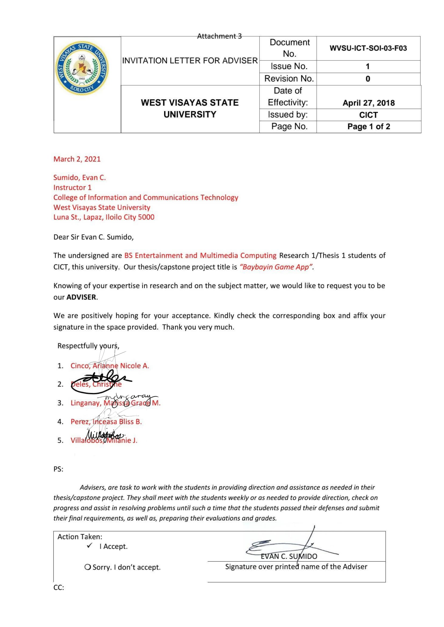Letter to the Adviser

Appendix B

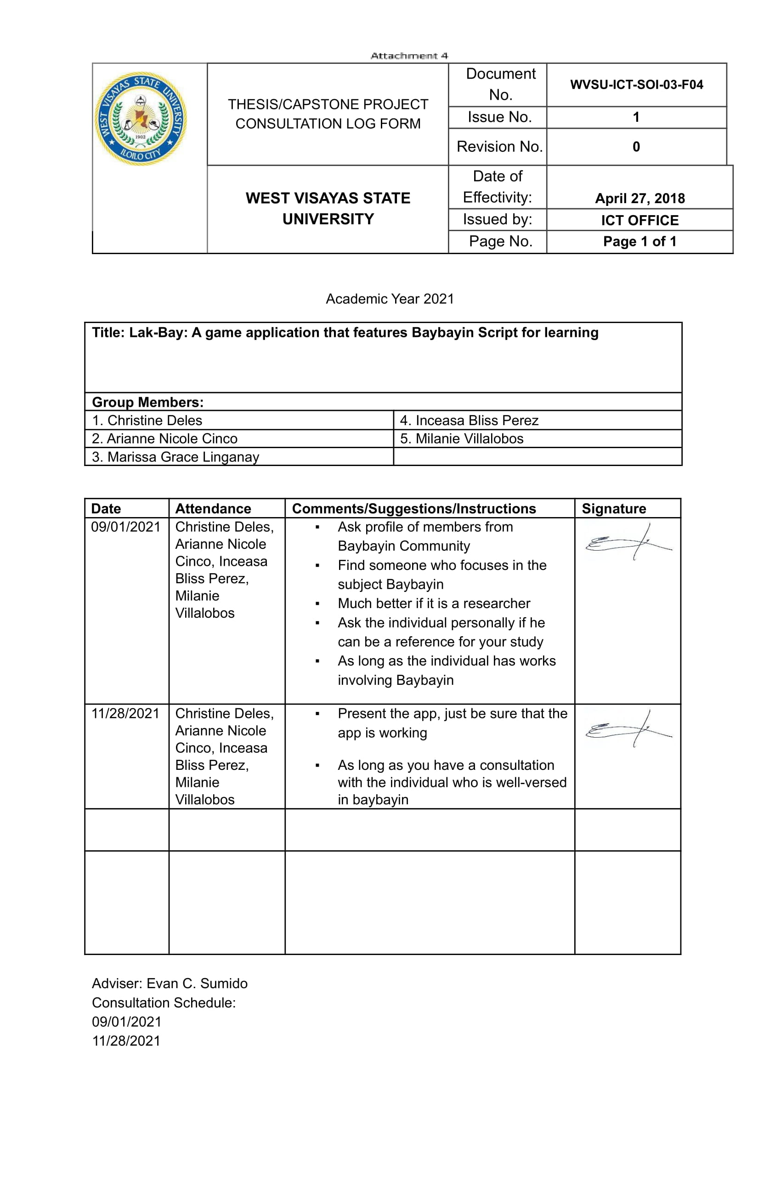Thesis Consultation Log Form

Appendix C

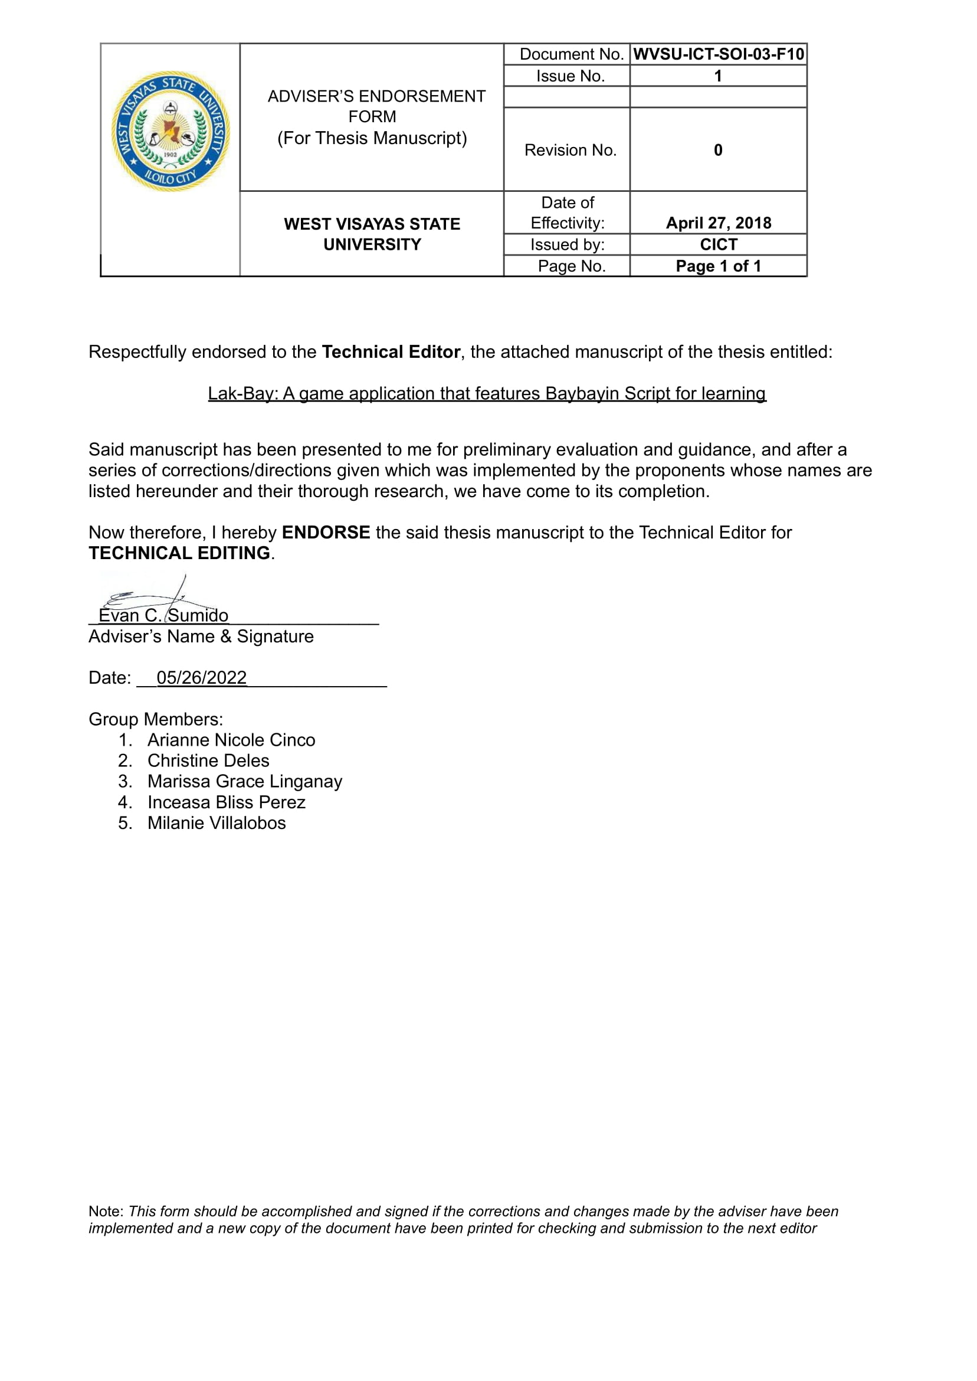Adviser Recommendation Form

Appendix D

Technical Editor Form



Appendix E

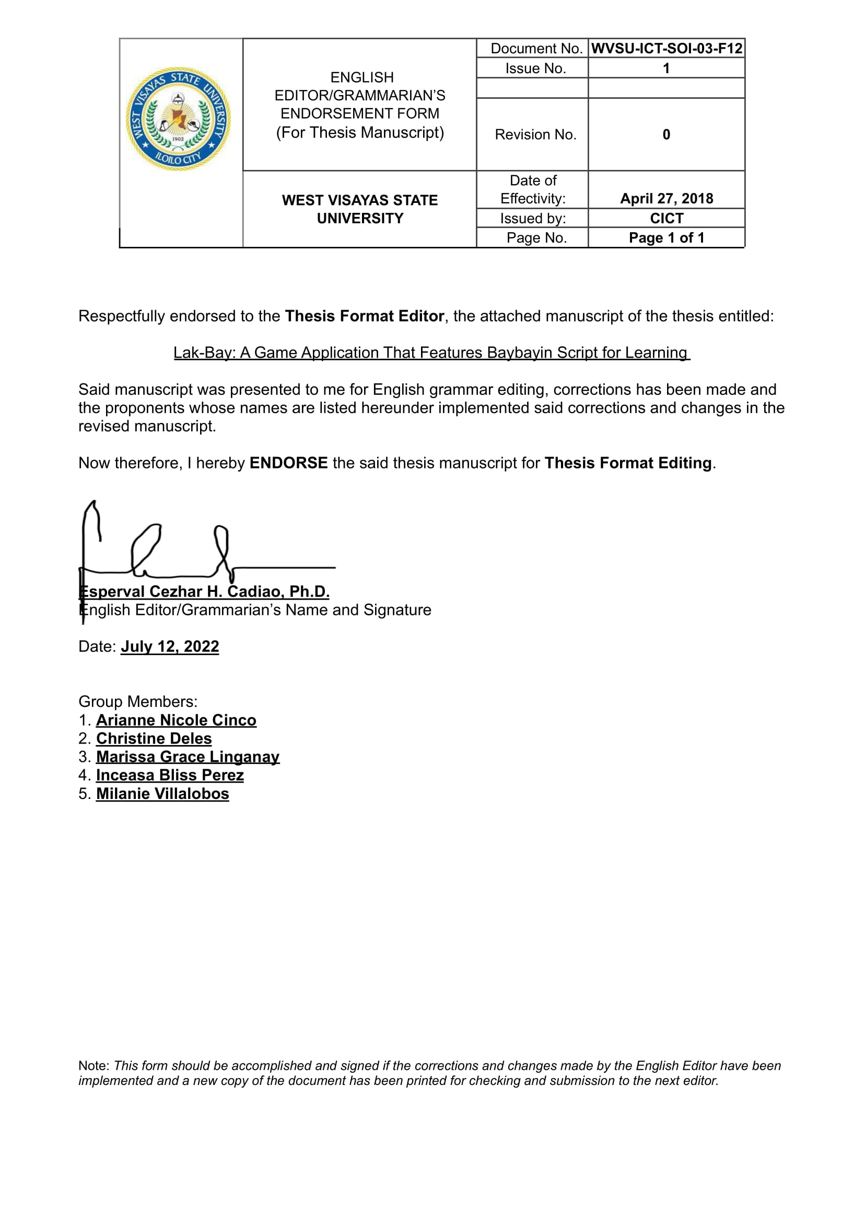English/Grammarian Editor Form

Appendix F

Thesis Format Editor Form

Appendix G

Certification for Bookbinding



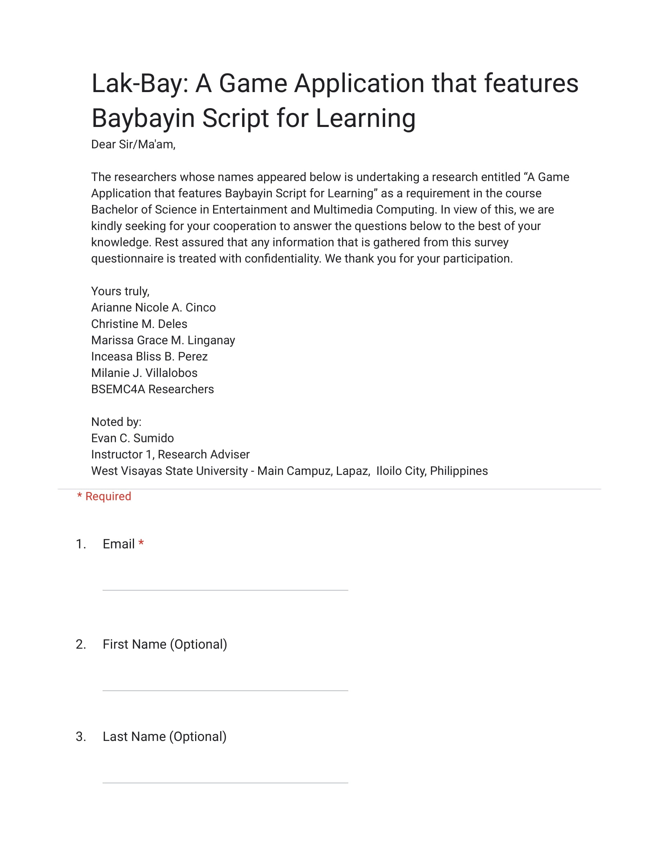Appendix H

Game Evaluation Form

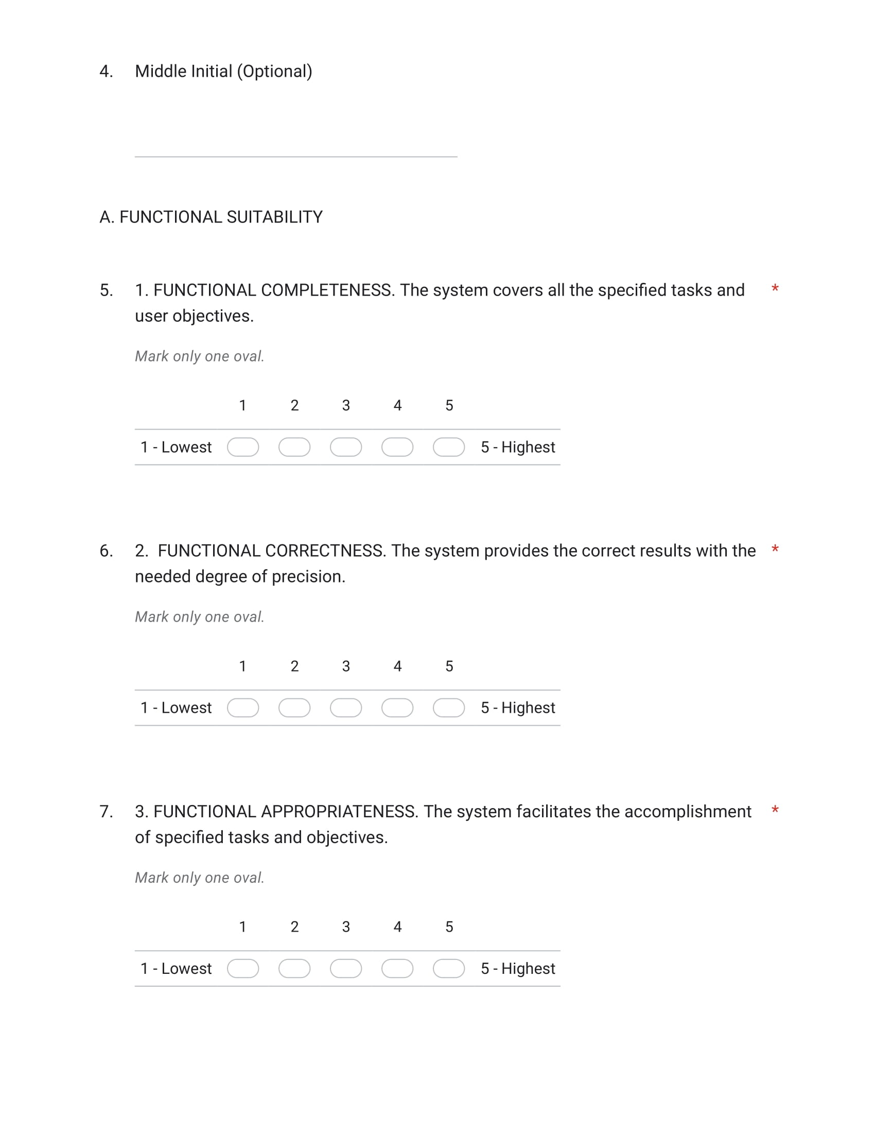

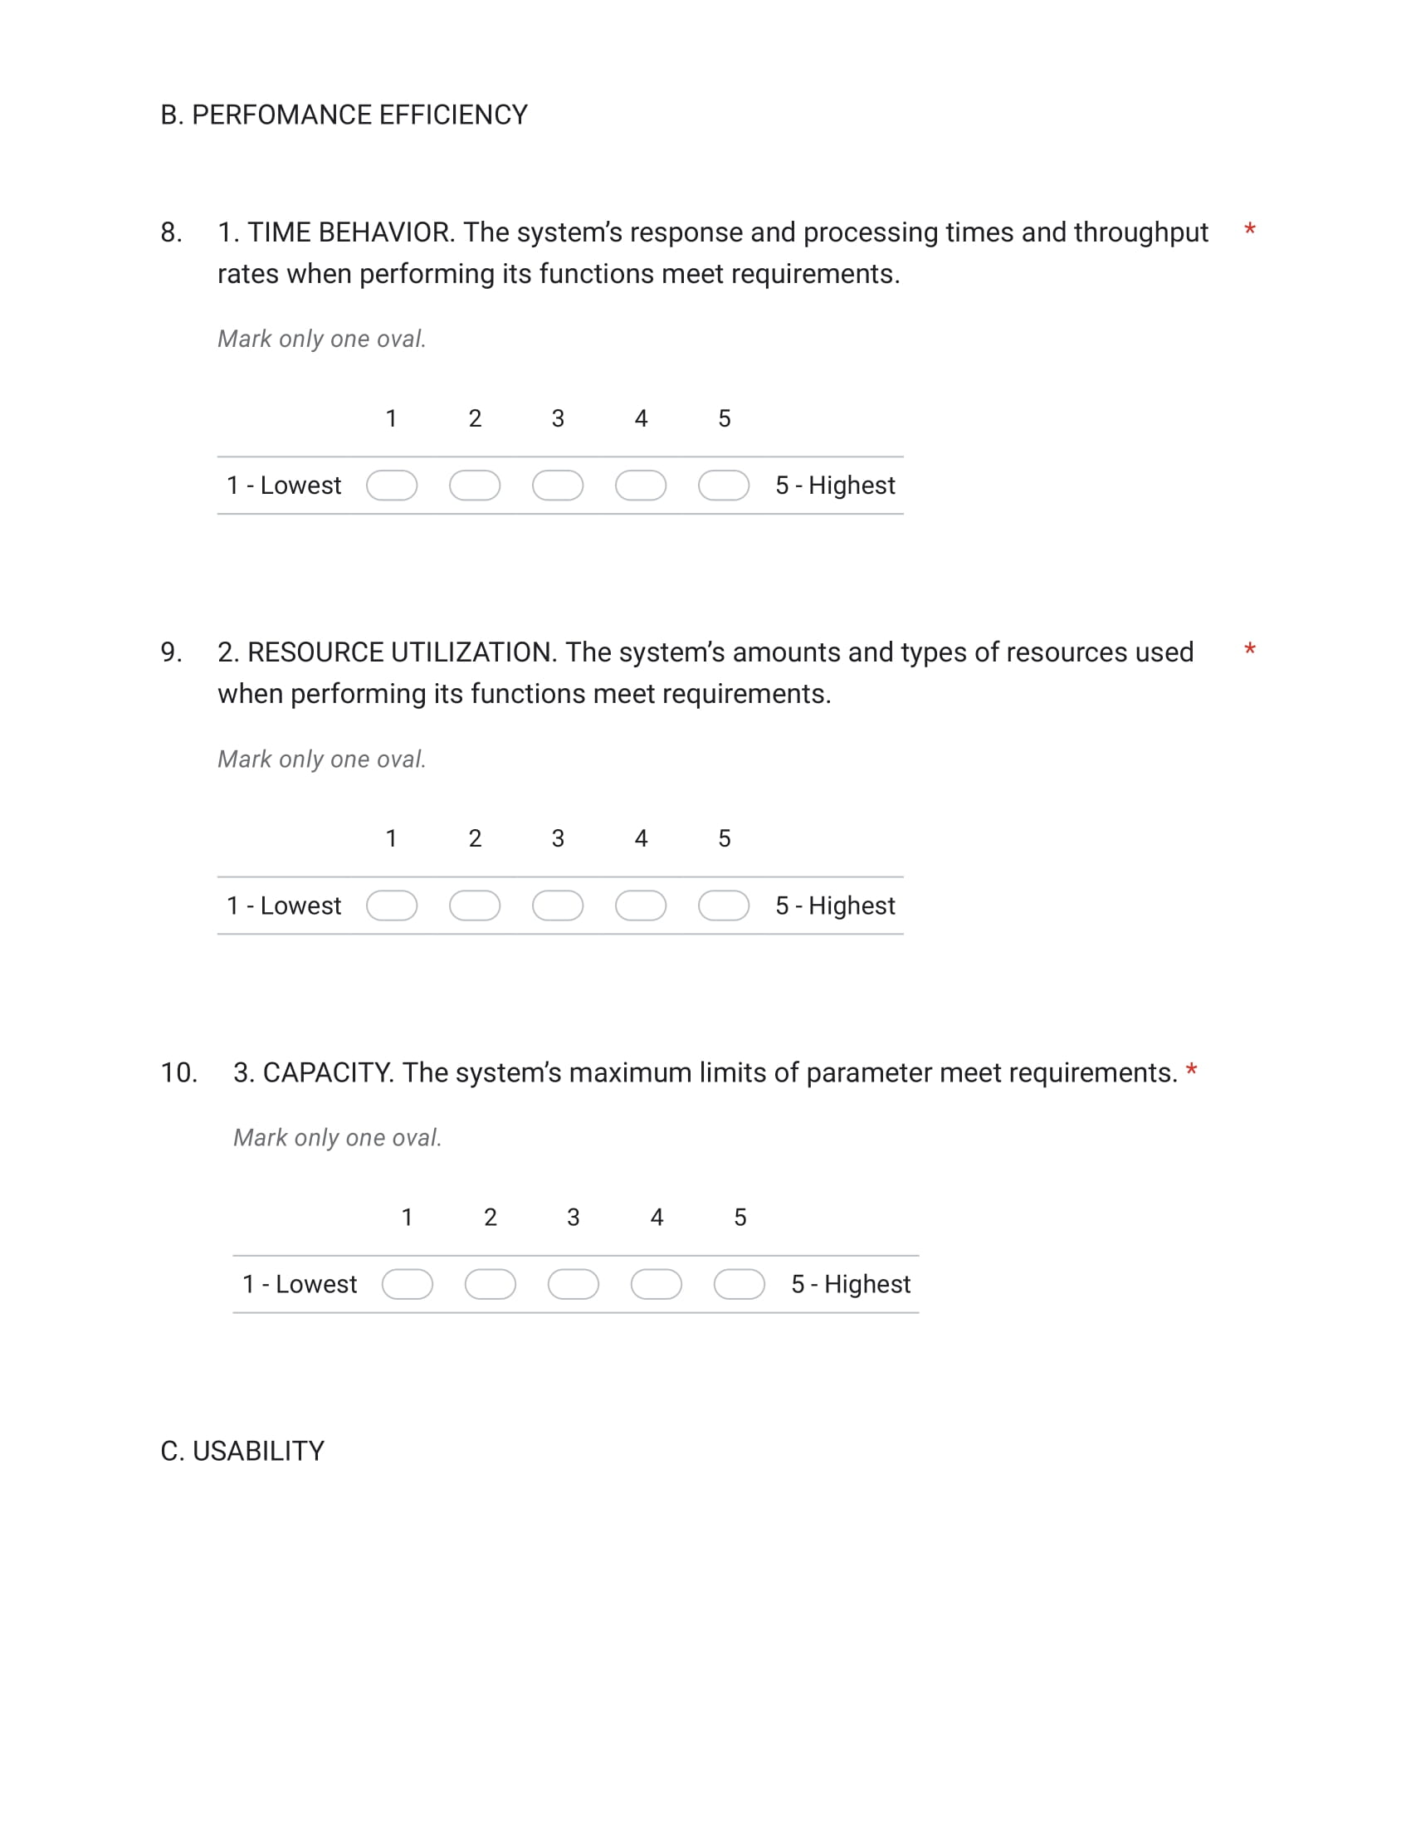

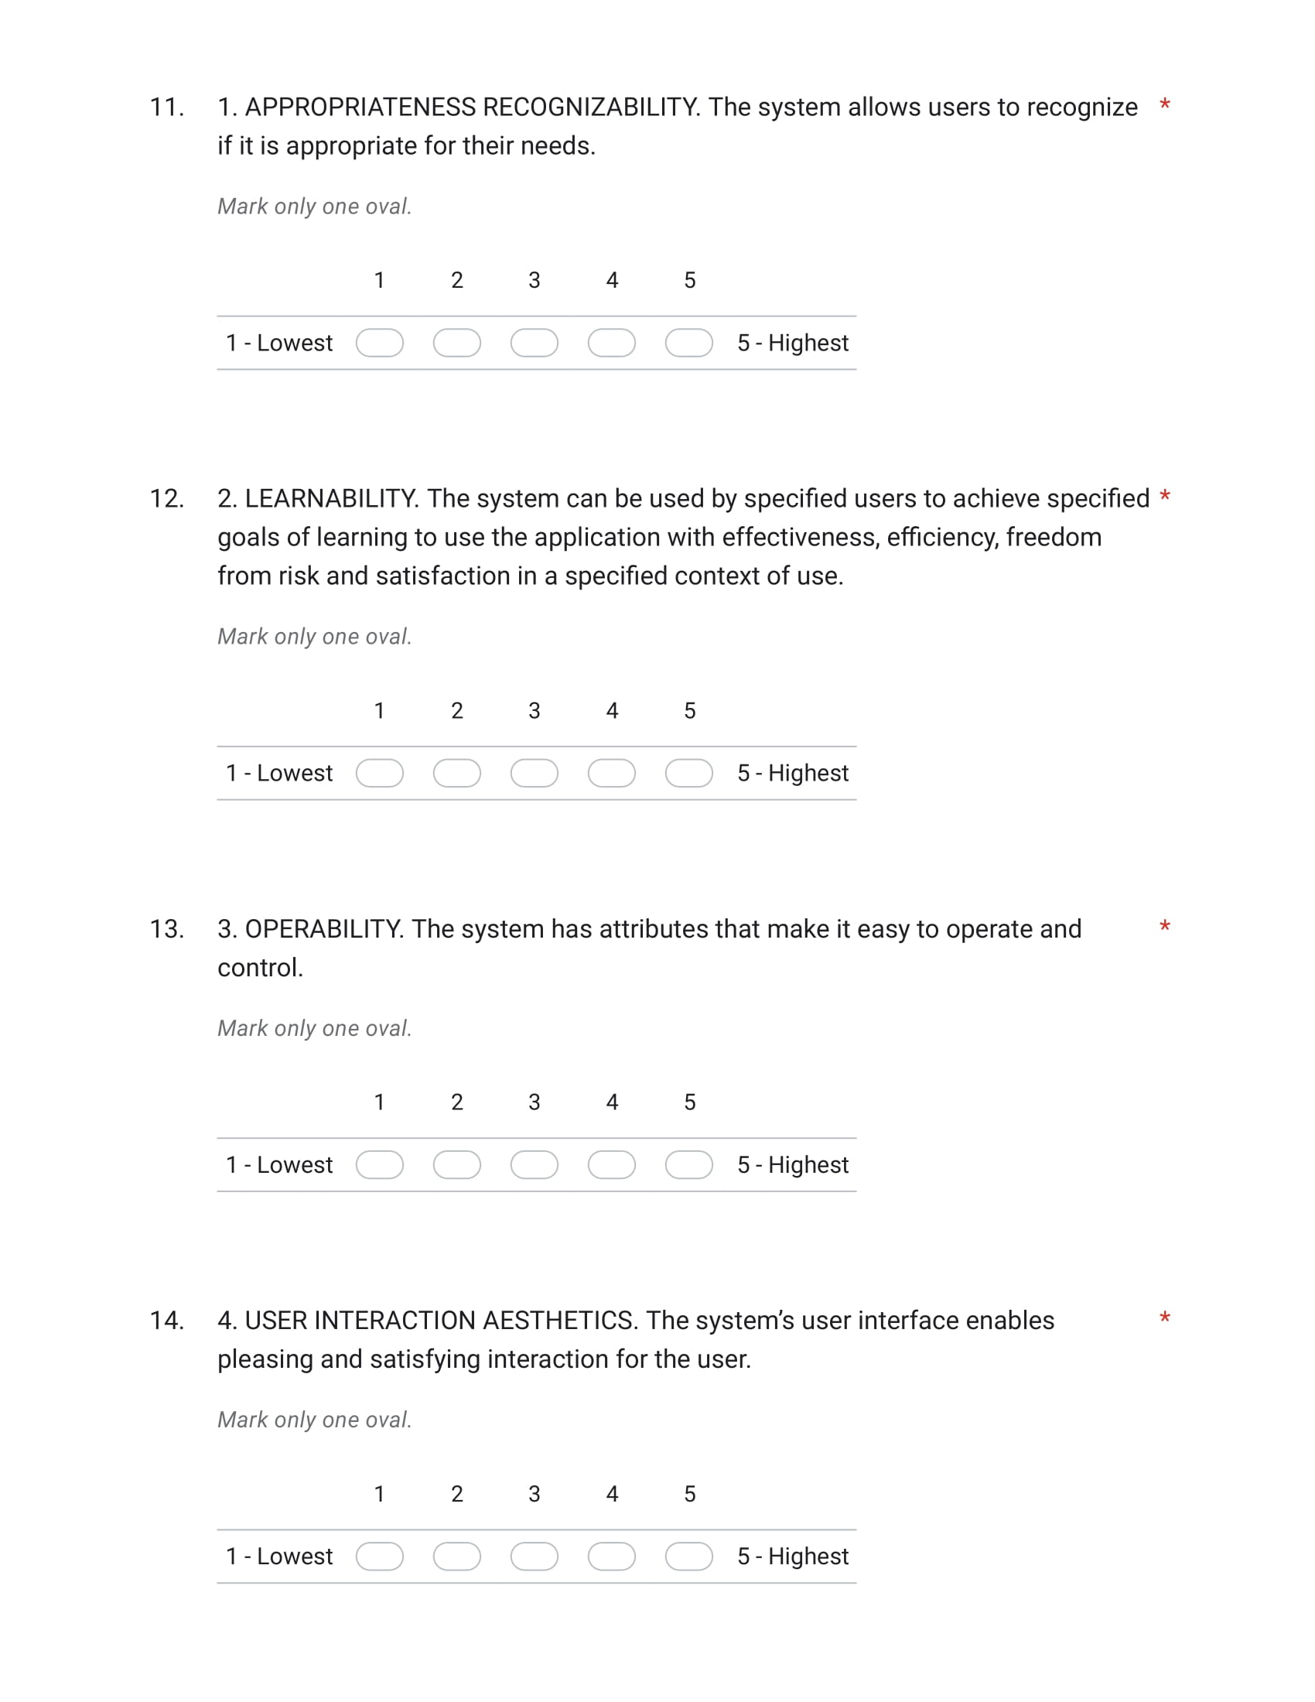

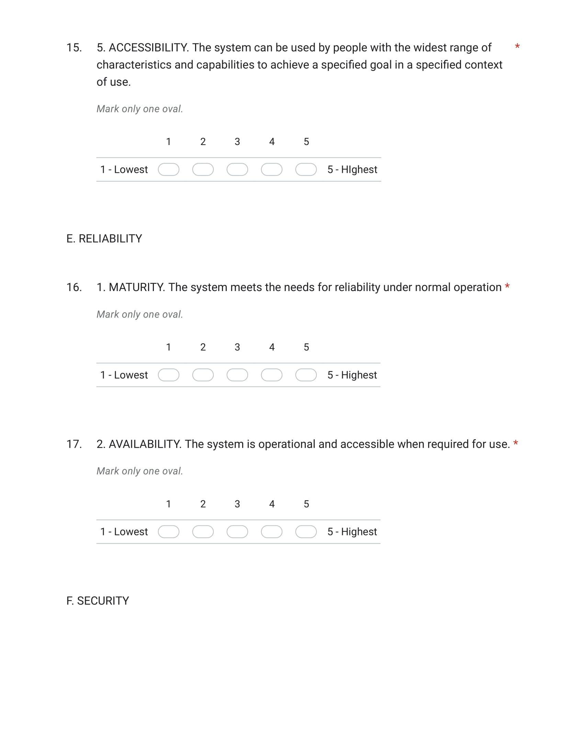

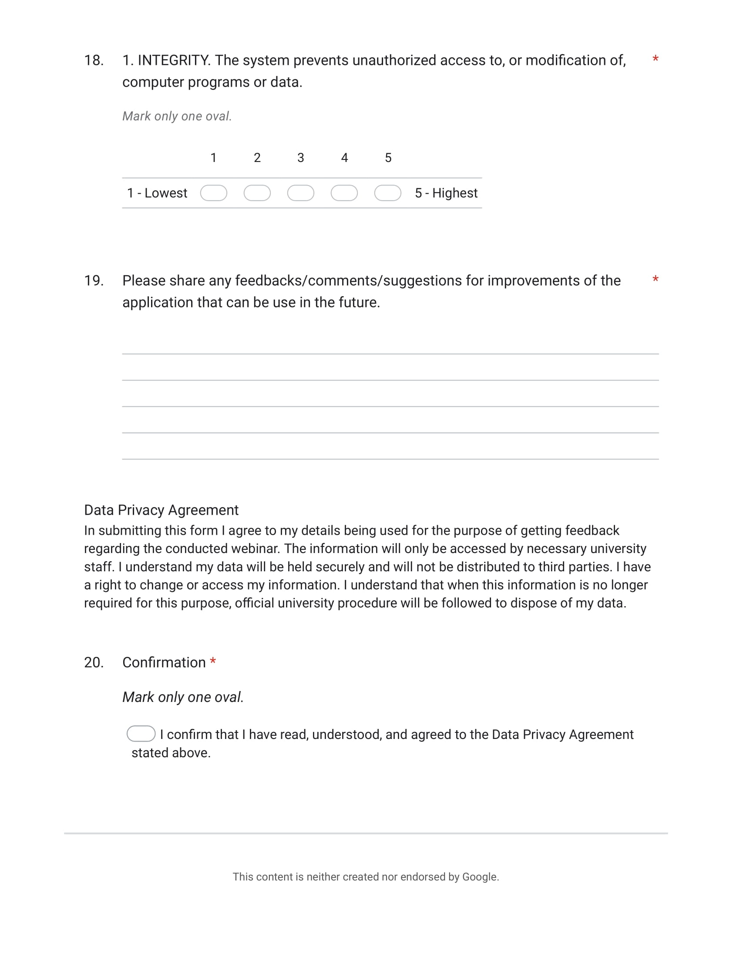

Appendix I

Scripts used in Game

**Quiz Manager**

using System.Collections;

using System.Collections.Generic;

using UnityEngine;

using UnityEngine.UI;

using UnityEngine.EventSystems;

using UnityEngine.SceneManagement;

public class LakbayQManager : MonoBehaviour

{

    public List<LakbayQandA> QnA;

    public GameObject[] options;

    public int currentQuestion;

    public GameObject Quizpanel;

    public GameObject GoPanel;

    public Text QuestionTxt;

    public Text ScoreTxt;

    int totalQuestions = 0;

    public int score;

    // public Animator animg;

    private void Start()

    {

        // animg.SetBool("GOpen", false);

        totalQuestions = QnA.Count;

        GoPanel.SetActive(false);

        generateQuestion();

    }

    public void retry()

    {       SceneManager.LoadScene(SceneManager.GetActiveScene().buildIndex); //loadscene

    }

    public void GameOver()

    {

        Quizpanel.SetActive(false);

        GoPanel.SetActive(true);

        // animg.SetBool("GOpen", true);

        ScoreTxt.text =  score + "/" + totalQuestions;

    }

    public void correct()

    {

        score += 1;

        QnA.RemoveAt(currentQuestion);

        generateQuestion();

    }

    public void wrong() //when answer is wrong

    {

        QnA.RemoveAt(currentQuestion);

        generateQuestion();

    }

    void SetAnswers()

    {

        for (int i = 0; i < options.Length; i++)

        {

            options[i].GetComponent<LakbayAnswerScript>().isCorrect = false;

            // options[i].transform.GetChild(0).GetComponent<Text>().text = QnA[currentQuestion].Answers[i];       options[i].transform.GetChild(0).GetComponent<Image>().sprite = QnA[currentQuestion].Answers[i];

  if(QnA[currentQuestion].CorrectAnswer == i+1)

            {            options[i].GetComponent<LakbayAnswerScript>().isCorrect = true;

            }

        }

    }

    void generateQuestion()

    {

        if(QnA.Count > 0)

        {

        currentQuestion = Random.Range(0, QnA.Count);

     QuestionTxt.text = QnA[currentQuestion].Question;

        SetAnswers();

    }

    else

    {

        Debug.Log("Out of Questions");

        //GameOver();

    }

    }

}

**Heart System**

using System.Collections;

using System.Collections.Generic;

using UnityEngine;

using UnityEngine.UI;

using UnityEngine.EventSystems;

using UnityEngine.SceneManagement;

public class HeartSystem : MonoBehaviour

{

    public GameObject[] hearts;

    public GameObject[] ehearts; //enemy

    private int life;

    private int elife; //enemy

    private bool dead;

    private bool edead; //enemy

    public Animator animg;

    public Animator animn;

    public Timer timer;

    private void Start()

    {

        life = hearts.Length;

        elife = ehearts.Length; //enemy

        animg.SetBool("GOpen", false);

        animn.SetBool("NSOpen", false);

        // animrun.SetBool("isRunning", false);

    }

    public void Update()

    {

        if (dead == true)

        {

            Destroy (GameObject.FindWithTag("Player"), .50f);

            timer.StopTime();

            // Invoke("waitforGOpen", 5);

            animg.SetBool("GOpen", true);

        }

        if (edead == true) //enemy

        {

            Destroy (GameObject.FindWithTag("Enemy"), .50f);

            timer.StopTime(); //pause countdown time

            // Invoke("waitforNSOpen", 5);

            animn.SetBool("NSOpen", true);

        }

    }

    public void TakeDamage(int d)

    {

        if (life >= 1)

        {

            life -= d;

            Destroy(hearts[life].gameObject);

        }

            if(life == 0)

            {

                dead = true;

            }

    }

    public void ETakeDamage(int e) //enemy

    {

        if (elife >= 1)

        {

            elife -= e;

            Destroy(ehearts[elife].gameObject);

            // Debug.Log("Runnnn");

        }

            if(elife == 0)

            {

                edead = true;

                animn.SetBool("NSOpen", true);

                Debug.Log("WIN");

            }

    }

    // public void waitforGOpen()

    // {

    //     animg.SetBool("GOpen", true);

    // }

    // public void waitforNSOpen()

    // {

    //     animn.SetBool("NSOpen", true);

    // }

}

**Answer Script**

using System.Collections;

using System.Collections.Generic;

using UnityEngine;

using UnityEngine.UI;

using UnityEngine.EventSystems;

public class LakbayAnswerScript : MonoBehaviour

{

    public bool isCorrect = false;

    public LakbayQManager lakbayqManager;

    public HeartSystem heartsystem;

    public HeartSystem eheartsystem;

    public int d;

    public int e;

    public Animator animrun;

    public Animator animenrun;

    // [SerializeField] private float timeInSeconds;

    public void Answer()

   {

       if (isCorrect)

       {

           Debug.Log("Correct Answer");

           lakbayqManager.correct();

           eheartsystem.ETakeDamage(e);

           runhit();

        //    animenrun.SetBool("Whit", false);

       }

       else

       {

           Debug.Log("Wrong Answer");

           lakbayqManager.wrong();

           heartsystem.TakeDamage(d);

           enrunhit();

        //    animrun.SetBool("Dhit", false);

       }

    }

    public void runhit()

    {

        animrun.CrossFade("MCrun", .70f);

        animrun.CrossFade("MCsword1", .20f);

        animrun.SetBool("Hit", false);

        animenrun.CrossFade("WLhit", .50f);

        animenrun.SetBool("Whit", false);

    }

    public void enrunhit()

    {

        animenrun.CrossFade("WLmove", .70f);

        animenrun.CrossFade("WLattack", .50f);

        animenrun.SetBool("Wattack", false);

        animrun.CrossFade("MChit", .50f);

        animrun.SetBool("Dhit", false);

    }

}

//heartsys file then ang take damage class nga halin sa muna nga file

**Timer**

using System.Collections;

using System.Collections.Generic;

using UnityEngine;

using UnityEngine.UI;

using UnityEngine.EventSystems;

public class Timer : MonoBehaviour

{

    public GameObject textDisplay;

    public int secondsLeft = 60;

    public bool takingAway = false;

    public HeartSystem hsanim;

    void Start()

    {

        textDisplay.GetComponent<Text>().text = "00:" + secondsLeft;

    }

    void Update()

    {

        if (takingAway == false && secondsLeft > 0)

        {

            StartCoroutine(TimerTake());

        }

        if (secondsLeft <= 0)

        {

            hsanim.animg.SetBool("GOpen", true);;

            StopCoroutine(TimerTake());

            StopTime();

        }

    }

    // void NoTime()

    // {

    //     if (secondsLeft == 0)

    //     {

    //         hsanim.Update();

    //         StopTime();

    //     }

    // }

    public void StopTime()

    {

        StopCoroutine(TimerTake());

        stopped = true;

        Debug.Log("STOP");

    }

    private bool stopped = false;

    IEnumerator TimerTake()

    {

        takingAway = true;

        // yield return new WaitForSeconds(1);

        // secondsLeft -= 1;

        // textDisplay.GetComponent<Text>().text = "00:" + secondsLeft;

        // takingAway = false;

        // stopped = false;

        int i = 0;

        stopped = false;

        do

        {

            yield return new WaitForSeconds(1);

            secondsLeft -= 1;

            textDisplay.GetComponent<Text>().text = "00:" + secondsLeft;

        }

            while(!stopped && i<1);

    }

}

**Pause Menu**

using System.Collections;

using System.Collections.Generic;

using UnityEngine;

using UnityEngine.SceneManagement;

public class PauseMenu : MonoBehaviour

{

    public static  bool GameIsPaused = false;

    public GameObject pauseMenuUI;

    public Timer timerp;

    // Update is called once per frame

    void Update()

    {

        if (Input.GetKeyDown(KeyCode.Escape))

        {

            if (GameIsPaused)

            {

                Resume();

            }

            else

            {

                Pause();

            }

        }

    }

    public void Resume() //public para mashow sa inspector

    {

        pauseMenuUI.SetActive(false);

        Time.timeScale = 1f; //normal time

        GameIsPaused = false;

    }

    void Pause()

    {

        pauseMenuUI.SetActive(true);

        Time.timeScale = 0f; //freez time or slowmo game

        GameIsPaused = true;

        timerp.StopTime();

    }

    public void LoadMenu()

    {

        Time.timeScale = 1f;

        SceneManager.LoadScene("Menu");

        // Debug.Log("Loading Menu..."); //paramashow lang sa console

    }

    public void QuitGame()

    {

        Application.Quit();

        // Debug.Log("Quitting Game...");//paramashow lang sa console

    }

    //dugang

    public void PauseB()

    {

        pauseMenuUI.SetActive(true);

        Time.timeScale = 0f;

    }

}

**Button Click Next**

using System.Collections;

using System.Collections.Generic;

using UnityEngine;

using UnityEngine.SceneManagement;

public class BUTTONCLICKNEXT : MonoBehaviour

{

    public void BUTTNEXT1()

    {

SceneManager.LoadScene(SceneManager.GetActiveScene().buildIndex + 1);

SfxManager.sfxInstance.Audio.PlayOneShot(SfxManager.sfxInstance.Click);

Bgmusic.bgmusic.Audio.PlayOneShot(Bgmusic.bgmusic.BGG);

    }

    public void BUTTNEXT2()

    {

SceneManager.LoadScene(SceneManager.GetActiveScene().buildIndex + 1);

SfxManager.sfxInstance.Audio.PlayOneShot(SfxManager.sfxInstance.Click);

Bgmusic.bgmusic.Audio.PlayOneShot(Bgmusic.bgmusic.BG1);

        Bgmusic.bgmusic.Audio.PlayOneShot(Bgmusic.bgmusic.Timer);

    }

    public void BUTTNEXT3()

    {

SceneManager.LoadScene(SceneManager.GetActiveScene().buildIndex + 1);    SfxManager.sfxInstance.Audio.PlayOneShot(SfxManager.sfxInstance.Click);

Bgmusic.bgmusic.Audio.PlayOneShot(Bgmusic.bgmusic.BG2);

Bgmusic.bgmusic.Audio.PlayOneShot(Bgmusic.bgmusic.Timer);

    }

    public void BUTTNEXT4()

    {

SceneManager.LoadScene(SceneManager.GetActiveScene().buildIndex + 1);

SfxManager.sfxInstance.Audio.PlayOneShot(SfxManager.sfxInstance.Click);

Bgmusic.bgmusic.Audio.PlayOneShot(Bgmusic.bgmusic.BG3);  Bgmusic.bgmusic.Audio.PlayOneShot(Bgmusic.bgmusic.Timer);

    }

    public void BUTTNEXT5()

    {

SceneManager.LoadScene(SceneManager.GetActiveScene().buildIndex + 1); SfxManager.sfxInstance.Audio.PlayOneShot(SfxManager.sfxInstance.Click);

Bgmusic.bgmusic.Audio.PlayOneShot(Bgmusic.bgmusic.BG4);

Bgmusic.bgmusic.Audio.PlayOneShot(Bgmusic.bgmusic.Timer);

    }

    public void BUTTNEXTB1()

    {

SceneManager.LoadScene(SceneManager.GetActiveScene().buildIndex + 1); SfxManager.sfxInstance.Audio.PlayOneShot(SfxManager.sfxInstance.Click);

Bgmusic.bgmusic.Audio.PlayOneShot(Bgmusic.bgmusic.BGB1);

    }

    public void BUTTNEXTB2()

    {

SceneManager.LoadScene(SceneManager.GetActiveScene().buildIndex + 1);

SfxManager.sfxInstance.Audio.PlayOneShot(SfxManager.sfxInstance.Click);

Bgmusic.bgmusic.Audio.PlayOneShot(Bgmusic.bgmusic.BGB2);

    }

    public void BUTTNEXTB3()

    {

SceneManager.LoadScene(SceneManager.GetActiveScene().buildIndex + 1);

SfxManager.sfxInstance.Audio.PlayOneShot(SfxManager.sfxInstance.Click);

Bgmusic.bgmusic.Audio.PlayOneShot(Bgmusic.bgmusic.BGB3);

    }

    public void BUTTNEXTB4()

    { SceneManager.LoadScene(SceneManager.GetActiveScene().buildIndex + 1);

SfxManager.sfxInstance.Audio.PlayOneShot(SfxManager.sfxInstance.Click);

Bgmusic.bgmusic.Audio.PlayOneShot(Bgmusic.bgmusic.BGB4);

    }

    public void BUTTNEXTBTR2()

    {

SceneManager.LoadScene(SceneManager.GetActiveScene().buildIndex + 1);

SfxManager.sfxInstance.Audio.PlayOneShot(SfxManager.sfxInstance.Click);

Bgmusic.bgmusic.Audio.PlayOneShot(Bgmusic.bgmusic.BTR2);

    }

    public void BUTTNEXTR2()

    {

SceneManager.LoadScene(SceneManager.GetActiveScene().buildIndex + 1);

SfxManager.sfxInstance.Audio.PlayOneShot(SfxManager.sfxInstance.Click);  Bgmusic.bgmusic.Audio.PlayOneShot(Bgmusic.bgmusic.BG21);

    }

    public void BUTTNEXTEND()

    {   SceneManager.LoadScene(SceneManager.GetActiveScene().buildIndex + 1);

SfxManager.sfxInstance.Audio.PlayOneShot(SfxManager.sfxInstance.Click);

        Bgmusic.bgmusic.Audio.Stop();

Bgmusic.bgmusic.Audio.PlayOneShot(Bgmusic.bgmusic.Menu);

    }

    public void BUTTNEXTLR2()

    {

        Bgmusic.bgmusic.Audio.Stop();

SfxManager.sfxInstance.Audio.PlayOneShot(SfxManager.sfxInstance.Click);

        Time.timeScale = 1f;

        SceneManager.LoadScene("ZLAST");

    }

    public void BUTTNEXTMENU()

    {

        Bgmusic.bgmusic.Audio.Stop();

SfxManager.sfxInstance.Audio.PlayOneShot(SfxManager.sfxInstance.Click);

        Time.timeScale = 1f;

        SceneManager.LoadScene("Menu");

    }

}

**Dialogue Manager**

using System.Collections;

using System.Collections.Generic;

using UnityEngine;

using UnityEngine.UI;

public class DManager : MonoBehaviour

{

    public Text nameText;

    public Text dialogueText;

    public float textSpeed; //dugang

    // bool IsOpen; //iba nga dugang

    // bool RLOpen; //iba nga dugang

    public Animator animator;

    public Animator anim2; //dugang nga animator

    private Queue<string> sentences;

    void Start()

    {

Bgmusic.bgmusic.Audio.PlayOneShot(Bgmusic.bgmusic.BGI);

        // Bgmusic.bgmusic.Audio.PlayOneShot(Bgmusic.bgmusic.BG1);

        // Bgmusic.bgmusic.Audio.PlayOneShot(Bgmusic.bgmusic.BG2);

        // Bgmusic.bgmusic.Audio.PlayOneShot(Bgmusic.bgmusic.BG3);

        // Bgmusic.bgmusic.Audio.PlayOneShot(Bgmusic.bgmusic.BG4);

        sentences = new Queue<string>();

        // animator = gameObject.GetComponent<Animator>(); //iba nga dugang

        // IsOpen = true;

        // RLOpen = false;

    }

    public void StartDialogue (Dialogue dialogue)

    {

        animator.SetBool("IsOpen", true);

        anim2.SetBool("RLOpen", false); //dugang para sa left and right

        animator.SetBool("IsOpen", true);

        Debug.Log("Starting conversation with " + dialogue.cname);

        nameText.text = dialogue.cname;

        sentences.Clear();

        foreach (string sentence in dialogue.sentences)

        {

            sentences.Enqueue(sentence);

        }

        DisplayNextSentence();

    }

    public void DisplayNextSentence ()

    {

SfxManager.sfxInstance.Audio.PlayOneShot(SfxManager.sfxInstance.Click);

        if (sentences.Count == 0)

        {

            EndDialogue();

            OpenChoice();

            return;

        }

        string sentence = sentences.Dequeue();

        // Debug.Log(sentence);

        //dialogueText.text = sentence; //ginchange sa coroutine

        StopAllCoroutines();

        StartCoroutine(TypeSentence(sentence));

    }

    IEnumerator TypeSentence (string sentence)

    {

        dialogueText.text = "";

        foreach (char letter in sentence.ToCharArray())

        {

            dialogueText.text += letter;

            // yield return null; //ginchange ko ang source

            yield return new WaitForSeconds(textSpeed);

        }

    }

    void EndDialogue()

    {

        animator.SetBool("IsOpen", false);

        // Debug.Log("End of Story.");

        Bgmusic.bgmusic.Audio.Stop();

    }

    void OpenChoice()

    {

        anim2.SetBool("RLOpen", true); //dugangpara sa controls to next scene

    }

}

**SfxManager**

using System.Collections;

using System.Collections.Generic;

using UnityEngine;

public class SfxManager : MonoBehaviour

{

public AudioSource Audio;

public AudioClip Click;

public AudioClip Correct;

public AudioClip Wrong;

// public AudioClip Win;

// public AudioClip Lose;

public static SfxManager sfxInstance;

private void Awake()

{

if (sfxInstance != null && sfxInstance != this)

{

    Destroy(this.gameObject);

    return;

}

sfxInstance = this;

DontDestroyOnLoad(this);

}

}

**Baybayin Lesson Change Image**

using System.Collections;

using System.Collections.Generic;

using UnityEngine;

using UnityEngine.UI;

public class LBChangeImage : MonoBehaviour

{

public Image startingImage;

public Sprite spriteOne;

public Sprite spriteTwo;

public Sprite spriteThree;

// public Sprite spriteFour;

public int imageNumber = 0;

public Animator animbutt; //button animation

public Animator animcont;

public Animator animbb; //Baybayin Lesson Text

void Start()

    {        // Bgmusic.bgmusic.Audio.PlayOneShot(Bgmusic.bgmusic.BGB1);

        animbutt.SetBool("BTOpen", true);

        animcont.SetBool("CBOpen", false);

        animbb.SetBool("bbclose", false);

    }

public void WhenButtonClicked ()

{  SfxManager.sfxInstance.Audio.PlayOneShot(SfxManager.sfxInstance.Click);

    animbb.SetBool("bbclose", true);

    imageNumber++;

    if (imageNumber == 1)

        startingImage.sprite = spriteOne;

    if (imageNumber == 2)

        startingImage.sprite = spriteTwo;

    if (imageNumber == 3)

    {

        Bgmusic.bgmusic.Audio.Pause();

        startingImage.sprite = spriteThree;

        imageNumber = 0;

    }

    if (imageNumber == 0)

    {

        // Debug.Log("Gana");

        CloseButt();

        OpenContinue();

    }

}

    void CloseButt()

    {

        animbutt.SetBool("BTOpen", false);

    }

    void OpenContinue()

    {

        animcont.SetBool("CBOpen", true);

        Bgmusic.bgmusic.Audio.Stop();

    }

}

**BC Skip Button**

using System.Collections;

using System.Collections.Generic;

using UnityEngine;

public class BC : MonoBehaviour

{

    public GameObject skip = null; //add on new

    public GameObject skipex = null;

    public void Start()

    {

        skipex.SetActive(false);

        skip.SetActive(false);

        //ShowButton();

        StartCoroutine(WaitBFShow());

    }

    private void ShowButton()

    {

        skipex.SetActive(true);

        skip.SetActive(true);

    }

    IEnumerator WaitBFShow() //sawakASSS naggana na sa 12/14 huhu

    {

        // skip.SetActive(false);

        yield return new WaitForSeconds(10); //waitfewseconds

        skip.SetActive(true);

    }

}

**Region 2 Answer Script**

using System.Collections;

using System.Collections.Generic;

using UnityEngine;

using UnityEngine.UI;

using UnityEngine.EventSystems;

public class Region2AnswerScript : MonoBehaviour

{

    public bool isCorrect = false;

    public R2QManager RlakbayqManager;

    public HeartSystem heartsystem;

    public HeartSystem eheartsystem;

    public int d;

    public int e;

    public Animator animrun;

    public Animator animenrun;

    // [SerializeField] private float timeInSeconds;

    public void Answer()

   {

       if (isCorrect)

       {

SfxManager.sfxInstance.Audio.PlayOneShot(SfxManager.sfxInstance.Correct);

           Debug.Log("Correct Answer");

           RlakbayqManager.correct();

           eheartsystem.ETakeDamage(e);

           runhit();

        //    animenrun.SetBool("Whit", false);

       }

       else

       {   SfxManager.sfxInstance.Audio.PlayOneShot(SfxManager.sfxInstance.Correct);

           Debug.Log("Wrong Answer");

           RlakbayqManager.wrong();

           heartsystem.TakeDamage(d);

           enrunhit();

        //    animrun.SetBool("Dhit", false);

       }

    }

    public void runhit()

    {

        animrun.CrossFade("MCrun", .70f);

        animrun.CrossFade("MCsword1", .20f);

        animrun.SetBool("Hit", false);

        animenrun.CrossFade("SantelmoHit", .50f);

        animenrun.SetBool("Shit", false);

    }

    public void enrunhit()

    {

        animenrun.CrossFade("SantelmoAttack", .70f);

        animenrun.CrossFade("SantelmoAttackStay", .50f);

        animenrun.SetBool("Sattack", false);

        animrun.CrossFade("MChit", .50f);

        animrun.SetBool("Dhit", false);

    }

}

//heartsys file then ang take damage class nga halin sa muna nga file

**Region 2 Question Manager**

using System.Collections;

using System.Collections.Generic;

using UnityEngine;

using UnityEngine.UI;

using UnityEngine.EventSystems;

using UnityEngine.SceneManagement;

public class R2QManager : MonoBehaviour

{

    public List<LakbayQandA> QnA;

    public GameObject[] options;

    public int currentQuestion;

    public GameObject Quizpanel;

    public GameObject GoPanel;

    public Text QuestionTxt;

    public Text ScoreTxt;

    int totalQuestions = 0;

    public int score;

    // public Animator animg;

    private void Start()

    {

        // animg.SetBool("GOpen", false);

        totalQuestions = QnA.Count;

        GoPanel.SetActive(false);

        generateQuestion();

    }

    public void retry()

    {

        // SfxManager.sfxInstance.Audio.PlayOneShot(SfxManager.sfxInstance.Click);

   SceneManager.LoadScene(SceneManager.GetActiveScene().buildIndex); //loadscene

        Bgmusic.bgmusic.Audio.Stop();  Bgmusic.bgmusic.Audio.PlayOneShot(Bgmusic.bgmusic.BG21);

Bgmusic.bgmusic.Audio.PlayOneShot(Bgmusic.bgmusic.Timer);

    }

    public void GameOver()

    {

        Quizpanel.SetActive(false);

        GoPanel.SetActive(true);

        // animg.SetBool("GOpen", true);

        ScoreTxt.text =  score + "/" + totalQuestions;

        Bgmusic.bgmusic.Audio.Stop();

    }

    public void correct()

    {

        score += 1;

        QnA.RemoveAt(currentQuestion);

        generateQuestion();

    }

    public void wrong() //when answer is wrong

    {

        QnA.RemoveAt(currentQuestion);

        generateQuestion();

    }

    void SetAnswers()

    {

        for (int i = 0; i < options.Length; i++)

        {

  options[i].GetComponent<Region2AnswerScript>().isCorrect = false;         // options[i].transform.GetChild(0).GetComponent<Text>().text = QnA[currentQuestion].Answers[i];

options[i].transform.GetChild(0).GetComponent<Image>().sprite = QnA[currentQuestion].Answers[i];

            if(QnA[currentQuestion].CorrectAnswer == i+1)

            {   options[i].GetComponent<Region2AnswerScript>().isCorrect = true;

            }

        }

    }

    void generateQuestion()

    {

        if(QnA.Count > 0)

        {

        currentQuestion = Random.Range(0, QnA.Count);

        QuestionTxt.text = QnA[currentQuestion].Question;

        SetAnswers();

    }

    else

    {

        Debug.Log("Out of Questions");

        //GameOver();

    }

    }

}

**LB 4th Stage Tutorial**

using System.Collections;

using System.Collections.Generic;

using UnityEngine;

using UnityEngine.UI;

public class LB4thStageTutorial : MonoBehaviour

{

public Image startingImage;

public Sprite spriteOne;

public Sprite spriteTwo;

public Sprite spriteThree;

public Sprite spriteFour;

public Sprite spriteFive;

public Sprite spriteSix;

// public Sprite spriteFour;

public int imageNumber = 0;

public Animator animbutt; //button animation

public Animator animcont;

public Animator animbb; //Baybayin Lesson Text

void Start()

    {

        animbutt.SetBool("BTOpen", true);

        animcont.SetBool("CBOpen", false);

        animbb.SetBool("bbclose", false);

    }

public void WhenButtonClicked ()

{ SfxManager.sfxInstance.Audio.PlayOneShot(SfxManager.sfxInstance.Click);

    animbb.SetBool("bbclose", true);

    imageNumber++;

    if (imageNumber == 1)

        startingImage.sprite = spriteOne;

    if (imageNumber == 2)

        startingImage.sprite = spriteTwo;

    if (imageNumber == 3)

        startingImage.sprite = spriteThree;

    if (imageNumber == 4)

        startingImage.sprite = spriteFour;

    if (imageNumber == 5)

        startingImage.sprite = spriteFive;

    if (imageNumber == 6)

    {

        startingImage.sprite = spriteSix;

        imageNumber = 0;

    }

    if (imageNumber == 0)

    {

        // Debug.Log("Gana");

        CloseButt();

        OpenContinue();

    }

}

    void CloseButt()

    {

        animbutt.SetBool("BTOpen", false);

    }

    void OpenContinue()

    {

        animcont.SetBool("CBOpen", true);

        Bgmusic.bgmusic.Audio.Stop();

    }

}

**Lakbay Scene Switch**

using System.Collections;

using System.Collections.Generic;

using UnityEngine;

using UnityEngine.SceneManagement;

public class LakbaySceneSwitch : MonoBehaviour

{

    public void OnTriggerEnter2D ()

    {

        // SceneManager.LoadScene(3);

     SceneManager.LoadScene(SceneManager.GetActiveScene().buildIndex + 1);

    }

}

**Lakbay Load Menu**

using System.Collections;

using System.Collections.Generic;

using UnityEngine;

using UnityEngine.SceneManagement;

public class LakbayMenuB : MonoBehaviour

{

    private int currentSceneIndex;

    public void LoadMenu()

    {

        currentSceneIndex = SceneManager.GetActiveScene().buildIndex;

        PlayerPrefs.SetInt("Continue", currentSceneIndex);

        SceneManager.LoadScene(0);

    }

}

**Question Display**

using System.Collections;

using System.Collections.Generic;

using UnityEngine;

using UnityEngine.UI;

public class QuestionDisplay : MonoBehaviour

{

    public GameObject screenQuestion;

    public GameObject answerA;

    public GameObject answerB;

    public GameObject answerC;

    public GameObject answerD;

    void Start()

    {

        screenQuestion.GetComponent<Text>().text = "What is the meaning of Baybay in Baybayin?";

        answerA.GetComponent<Text>().text = "A. To see";

        answerB.GetComponent<Text>().text = "B. To write";

        answerC.GetComponent<Text>().text = "C. To run";

        answerD.GetComponent<Text>().text = "D. To sleep";

    }

    // Update is called once per frame

    void Update()

    {

    }

}

**Load Timer**

using System.Collections;

using System.Collections.Generic;

using UnityEngine;

using UnityEngine.SceneManagement;

public class LBTimerLoadScene : MonoBehaviour

{

    [SerializeField]

    private float delayBeforeLoading = 10f;

    [SerializeField]

    //private string sceneNameToLoad;

    private float timeElapsed;

    private void Update()

    {

        timeElapsed += Time.deltaTime;

        if (timeElapsed > delayBeforeLoading)

        {

          SceneManager.LoadScene(SceneManager.GetActiveScene().buildIndex + 1); //number sng scne plus pila para kakadto sa designated scene

    }

}

}

**Cut Scene to Intro Scene**

using System.Collections;

using System.Collections.Generic;

using UnityEngine;

using UnityEngine.SceneManagement;

public class CutSceneToIntroScence : MonoBehaviour

{

    public void CTtoIS ()

    {

        // SceneManager.LoadScene(5);

    SceneManager.LoadScene(SceneManager.GetActiveScene().buildIndex + 1); //number sng scne plus pila para kakadto sa designated scene   SfxManager.sfxInstance.Audio.PlayOneShot(SfxManager.sfxInstance.Click);

}

}

Appendix J

Disclaimer

This software project and its corresponding documentation  entitled “Lak-Bay: A game application that features Baybayin Script for learning” is submitted to the College of Information and Communications Technology, West Visayas State University, in partial fulfillment of the requirements for the degree, Bachelor of Science in Entertainment and Multimedia Computing. It is the product of our own work, except where indicated text.

We hereby grant the College of Information and Communications Technology permission to freely use, publish in local or international journal/conferences, reproduce, or distribute publicly the paper and electronic copies of this software project and its corresponding documentation in whole or in part, provided that we are acknowledged.

Cinco, Arianne Nicole A.

Deles, Christine M.

Linganay, Marissa Grace M.

Perez, Inceasa Bliss B.

Villalobos, Milanie J.

June 2022